Enterprise-level Multifunctional Fluid Control Gateway
manual of operation
V1.1

April 20,2023
catalogue
Enterprise-level Multi-functional Fluid Control Gateway 1 1
1. Product Overview 4 4
2. Log in to the WEB Interface 4 4
3. Be familiar with all the functions of the web page 4 4
3.1. System Status 4 4
Device Information 5 5
Interface Status 5 5
Internal network IP traffic: 6 6
Application Traffic 7 7
3.2. Network Configuration 7 7
Interface Configuration – External Network Configuration 8 8
Interface Configuration-Internal Network/DHCP 8 8
Interface Configuration-Physical Port Division 10 10
Routing Rules – Multi-Line Traffic Distribution Rule 11 11
Routing Rules – Static Routing 12 12
Dynamic Domain 12 13
NAT/Port Mapping 13 13
3.3. Epidemic Control Strategies 14 15
Intelligent Flow Control 14 15
Policy Speed Limit 14 15
Free Flow Control 15 16
3.4. AC Management 15 16
AP Device List 15 16
AP Configuration Template 17 18
AP Upgrade 18 19
Wireless Roaming 18 19
Automatic Channel 19 20
Audit Configuration and Server Location 20 20
3.5. Certified Access 21 21
Authentication Configuration 21 21
PPoS 21 22
Portal Authentication 22 23
Radius Billing 23 23
Authenticated User 23 24
authenticated user status 25 26
Department/Level Definition 25 26
3.6. Behavioral Control 26 27
Apply Firewall 26 27
URL Redirect 26 27
Domain Redirect 27 28
3.7. Object Management 28 29
Basic Object – Time Object 28 29
Basic Object – Source IP Object 28 29
Basic Object – Port Object 29 30
Basic Object – Destination IP Object 29 30
Application Object – Built-in Application Object 30 31
Application Object – Custom Application Object 31 32
3.8. Safety Protection 32 34
IP-MAC Binding 32 34
Connection Limit: 32 34
Internal Network Abnormality Detection 32 34
Internal Network Attack Protection 34 36
Ping access blocked to external network / External network login 34 36
3.9. Log Recording 35 37
User Authentication Log 35 37
Online User Count Log 35 37
Interface Traffic Log 36 38
System Log 36 38
3.10. VPN Applications 36 38
PPTP 36 38
L2TP 38 40
VTUNS 38 40
3.11. Equipment Maintenance 40 42
Device Upgrade 40 42
Password Change 40 42
Ping Test 41 43
Configuration File Maintenance 41 43
Reboot Device 43 45
Scheduled Task 43 45
Time Synchronization 44 46
Cloud Platform Configuration 44 46

Product Overview
This product is a multifunctional flow-control gateway wireless AC unit featuring multi-line diversion and load balancing capabilities, delivering high-capacity, high-performance, highly reliable wireless data control services with easy installation and maintenance. It offers flexible networking and energy-efficient advantages.

Log in to the Web Interface
  - After the gateway is powered on and starts up normally, the Run status indicator on the device will flash regularly. Connect the network cable to the LAN port to ensure proper network connectivity between the logged-in client devices and the gateway.
  - Enter 172.16.0.1:2011 in the browser; the default username and password are admin
After successful login, go to the homepage
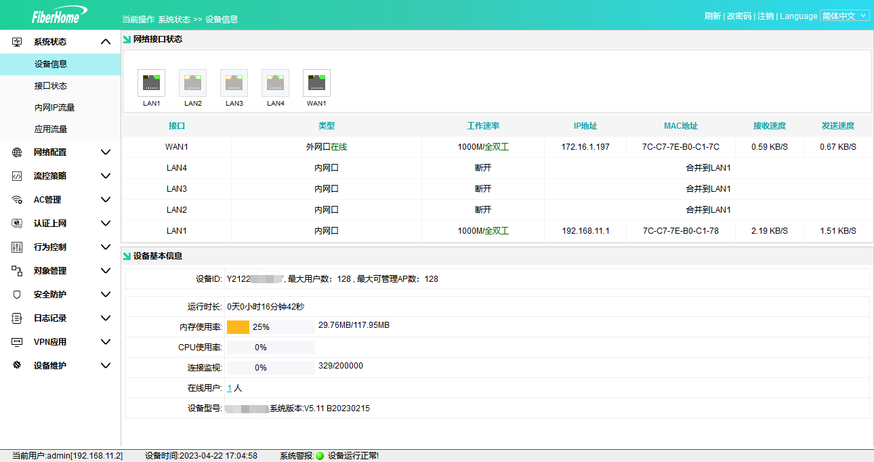
Figure 1 – Homepage

Familiar with all features of web pages

system mode
Displays comprehensive gateway information, including interface statuses, internal network client details, uplink and downlink speeds, real-time uplink and downlink speeds for each application, and total traffic.

facility information
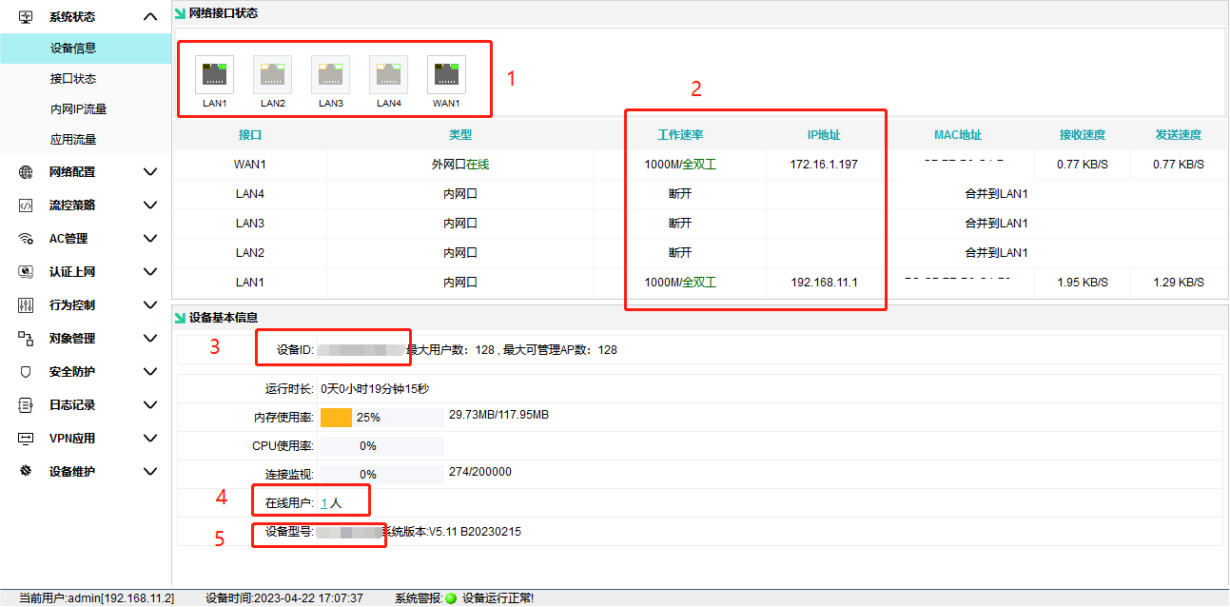
Device Information: Displays comprehensive gateway information
Number 1: Shows the physical connection status of the interface; colored icons indicate a connected connection
Number 2: IP address corresponding to the display interface
Number 3: Unique device ID for remote connection
Number 4: Number of terminals currently connected to the gateway, excluding APs.
Number 5: Display Device Model

Click on online users to filter APs and devices by user, IP, or MAC address, and view corresponding IP and MAC addresses.
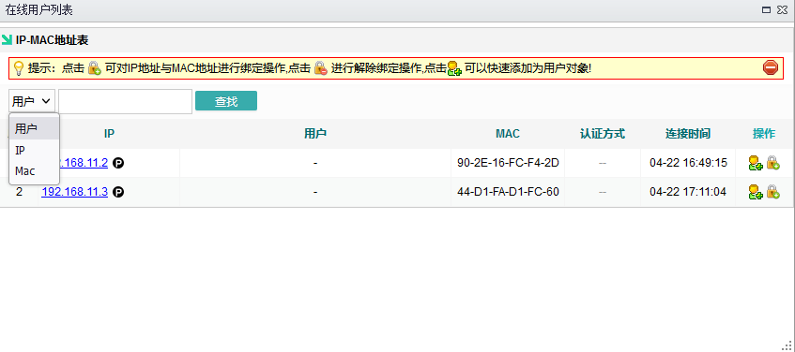

Interface State
View comprehensive information for each interface. View interface details and WAN port speed measurements.
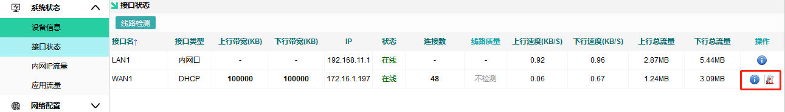
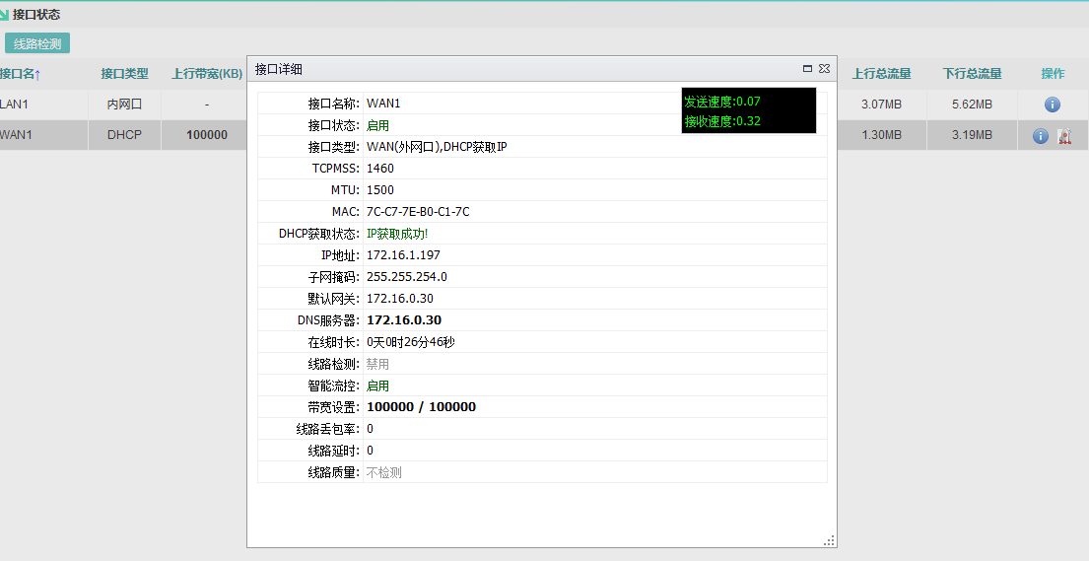

Internal Network IP Traffic
You can view traffic information for each internal network terminal's independent usage, as well as the link tracking table.
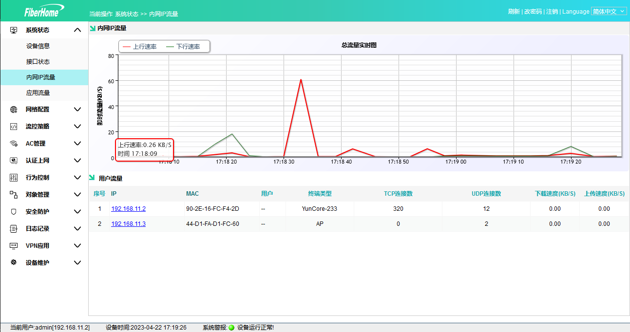
View this user's data type, speed, and number of connection protocols
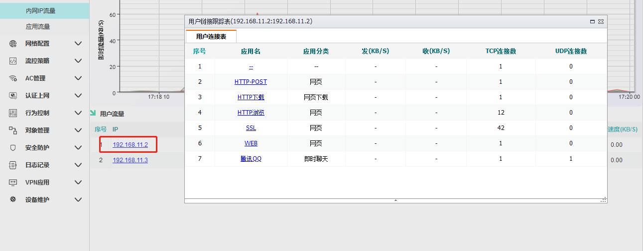

Application Traffic
View the proportion of downloads and uploads for each traffic type.
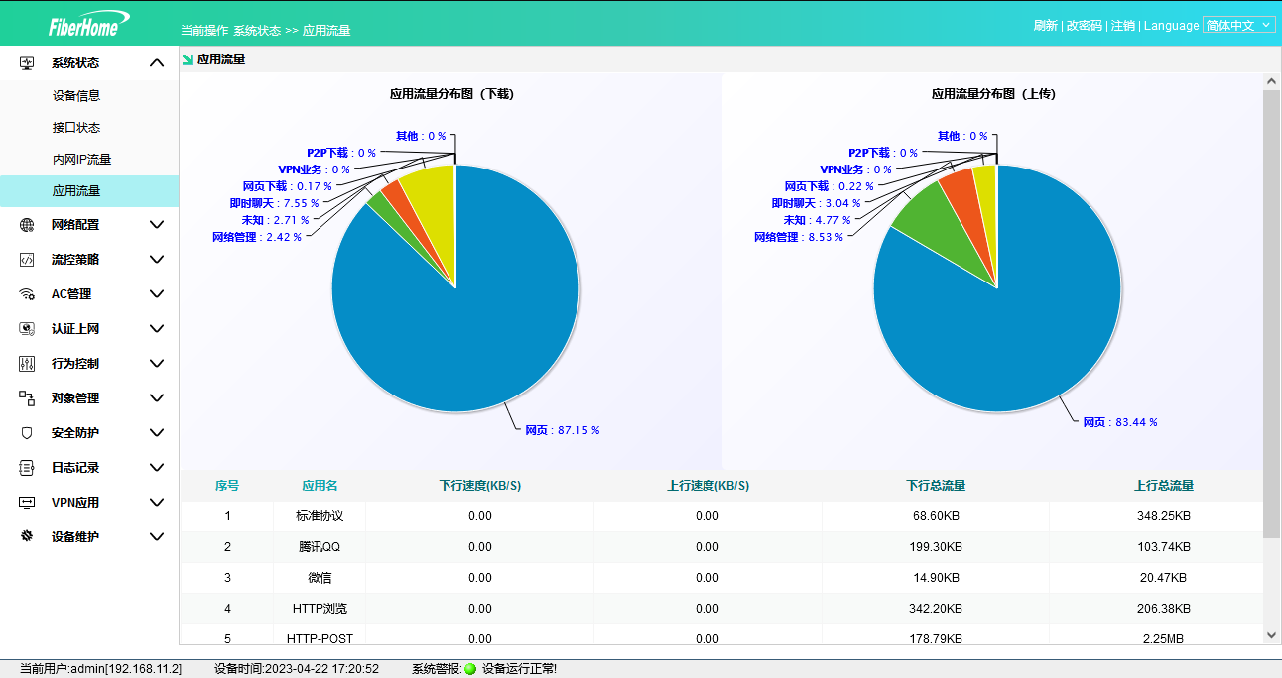

line configuration
Configuration information for setting up external and internal networks, including internal network routing

Interface Configuration – External Network Configuration
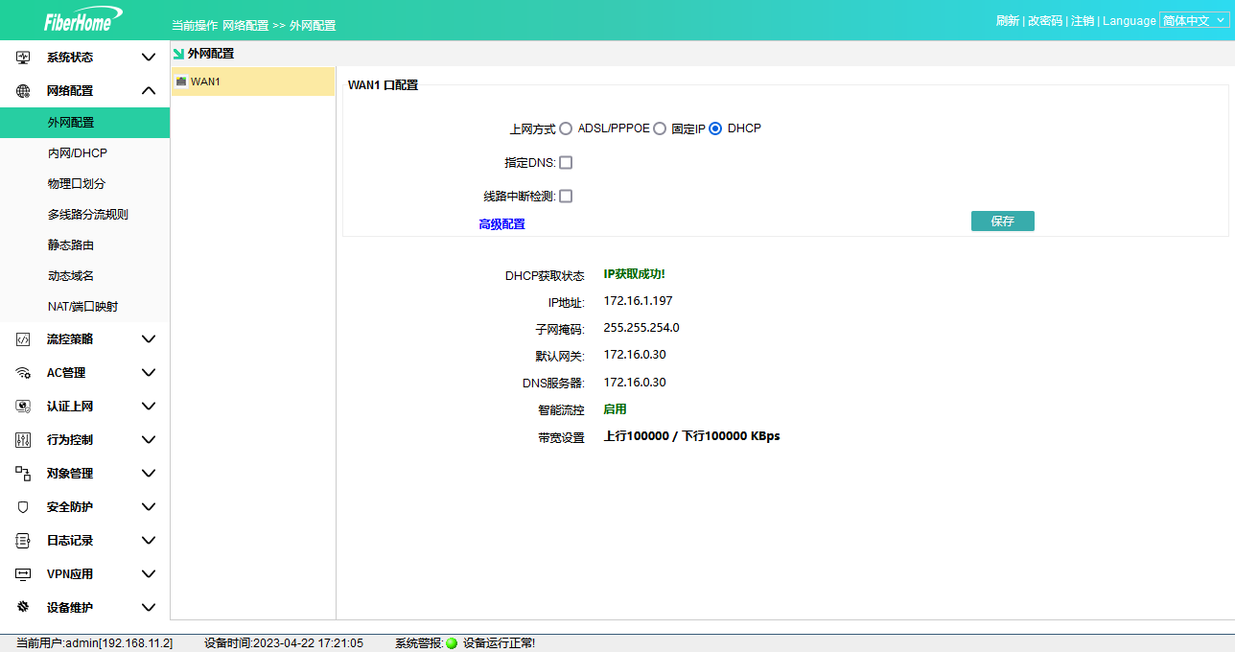
Internet connection method – Select the appropriate method based on your needs
- ADSL/PPPOE: Enter your broadband account and password
- Fixed IP: Enter the IP address, mask, gateway, and DNS provided by your carrier
- DHCP: Connect directly to the provider's network to obtain an IP address
Line interruption detection – Ping testing (114DNS, Tencent Official Website, Alibaba DNS, Baidu DNS): If consecutive pings fail, high latency occurs, and no data exchange is detected, the connection is flagged as abnormal. For poor-quality connections, dial-up attempts will be repeated, DHCP configurations reconfigured, and fixed IPs handled offline. Offline connections are excluded from load balancing. In multi-line environments, line interruption detection should be enabled to ensure automatic switching only when specific lines become offline.

Note: Dedicated network lines in Chengdu and Chongqing cannot be selected (cannot be tested); for certain dedicated lines, line testing cannot be enabled if the operator prohibits ping requests.

PING IP for detection: Default is 0.0.0.0, indicating use of built-in IPs (114DNS, Tencent official website, Alibaba DNS, Baidu DNS) for testing. If your local DNS can be pinged or another public IP with lower latency is available, enter it as the detection reference.

Note: This recommendation should be evaluated by a qualified technician before entering the test IP address.

Interface Configuration – Internal Network/DHCP
Number 1: LAN port address. By default, ports 1–4 belong to the same LAN and are used for accessing the AC.
Number 2: Configuration information for the IP segment allocated from the IP address pool; it must not match the IP segment obtained from the WAN port.
Number 3: DHCP static allocation, allowing managed binding of IP and MAC addresses.
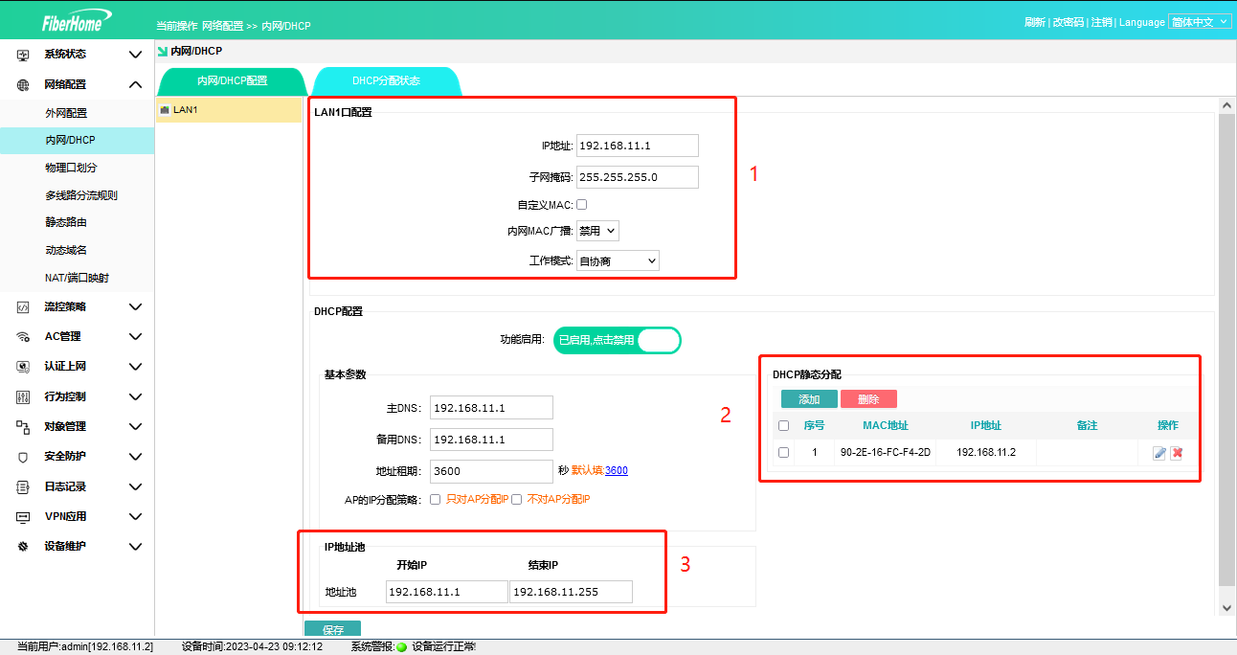

View DHCP allocation status records
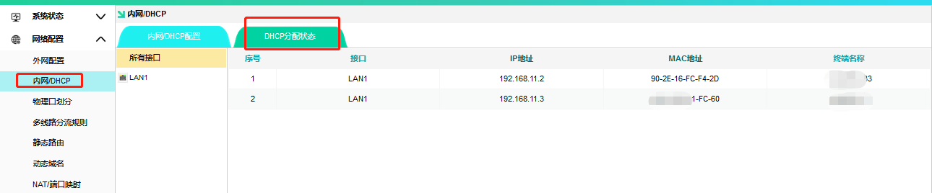

Note: If AC is connected via a bypass router, check "Assign IP only to AP".
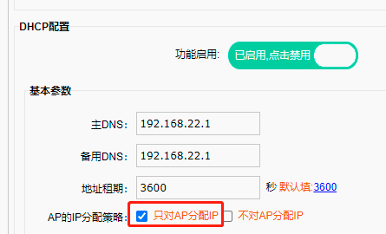

Interface Configuration – Physical Port Allocation
Used to divide multiple WAN ports and LAN ports according to requirements
Number 1: If you need to divide multiple LANs, uncheck this option; LANs 1–4 will have different addresses
Number 2: Enable hardware NAT forwarding to route data directly without passing through the CPU, improving network speed.
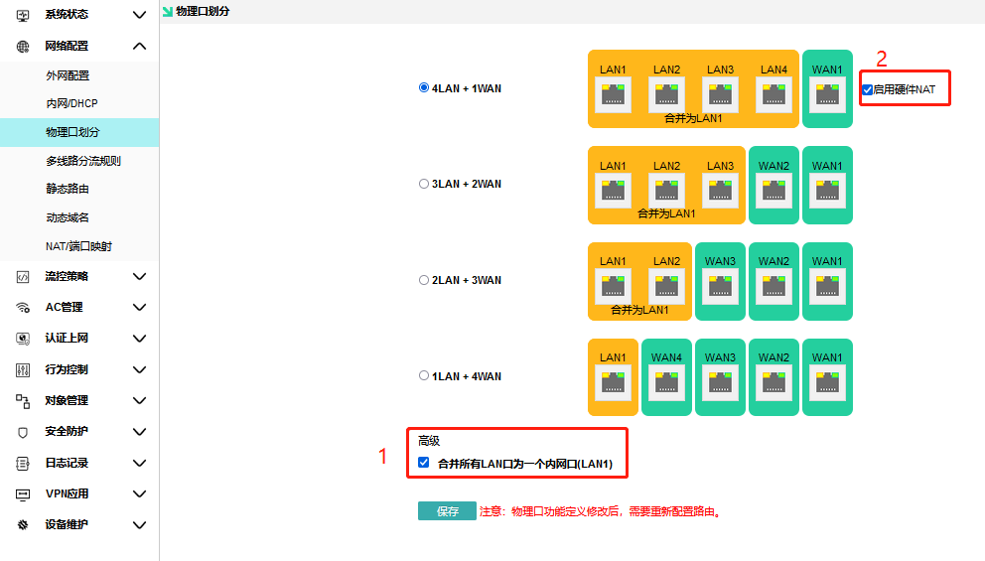

Interface Configuration – Sub-interface Configuration
Created for

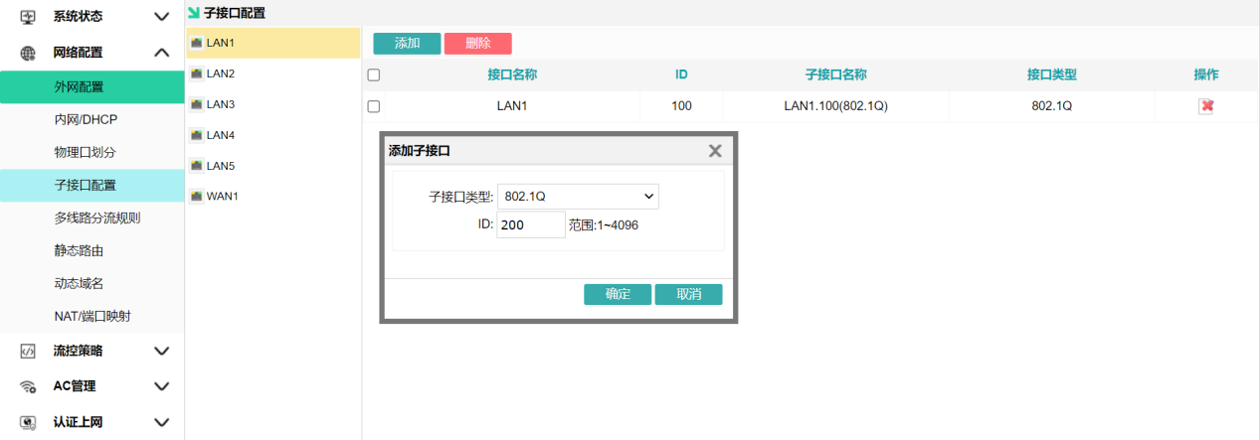

Routing Rules – Multi-path Traffic Distribution Rules
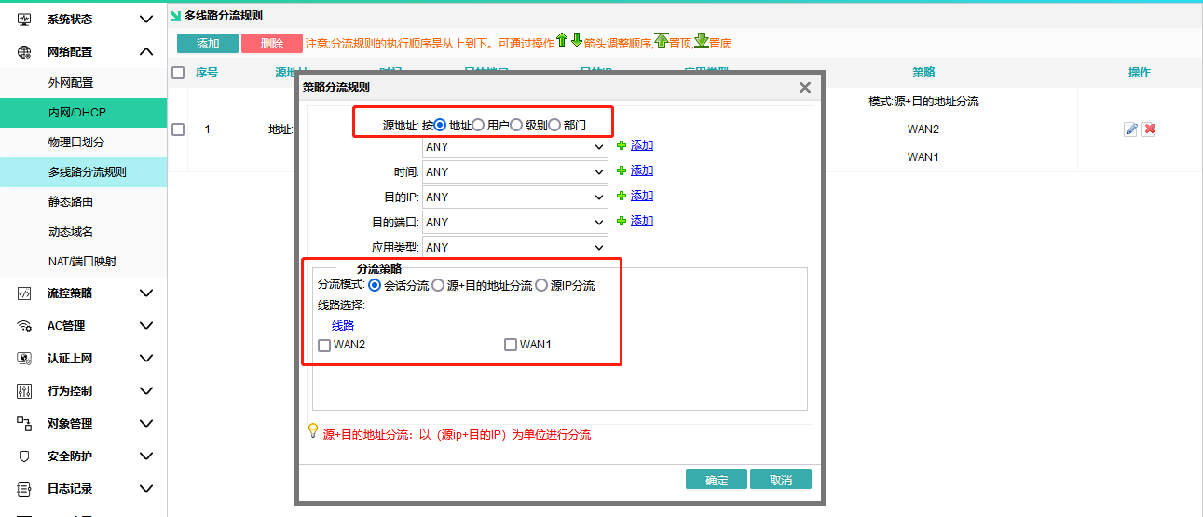
A single line does not require traffic distribution rules. When two or more WAN ports connect to the external network, you can configure different source addresses and traffic distribution modes, which are divided into three types:
- Session load balancing: Distributes all internet connections across multiple lines. For example, when Zhang San uses Xunlei for downloads, the software simultaneously sends numerous links, which are distributed across three lines. Each line generates traffic that returns to Xunlei, achieving bandwidth synergy.
- Source-plusDestination Address Traffic Distribution: Building upon session-based traffic distribution, the system identifies source and destination addresses to route traffic to respective network paths. For example, assume Zhang San simultaneously visits three websites—Industrial and Commercial Bank of China, JD.com, and Taobao—with their IP addresses denoted as A, B, and C respectively. Using this source-plusdestination address approach, all traffic is distributed across three external network paths. The final outcome is that Zhang San's requests to Industrial and Commercial Bank of China are routed exclusively through Path 1; those to JD.com through Path 2; and those to Taobao through Path 3.
- IP Traffic Distribution: Traffic is consistently routed through a single line based on source address. Taking an environment with three external networks serving nine users as an example, all users are assigned to these three networks respectively: Zhang San uses Line 1 exclusively; Li Si uses Line 2 exclusively; Wang Wu uses Line 3 exclusively; Zhao Liu uses Line 1 exclusively—each user is assigned to one fixed line accordingly. Since each user is dedicated to a specific line, their internet speed is limited by that line's bandwidth capacity.
Weight: Weight refers to a "proportion" and is only applicable for IP traffic distribution. Consider an environment with three external networks serving 12 users: all users are routed to these networks, with Line 1 assigned weight 3, Line 2 weight 2, and Line 3 weight 1. The distribution results are as follows: Line 1 handles 6 users, Line 2 handles 4 users, and Line 3 handles 2 users.

(Weight represents a ratio; for example, three lines with weights of 4, 2, and 1 result in a ratio of 4:2:1.)

Summary: IP traffic distribution is particularly suitable for networks with numerous connections, minimizing simultaneous IP usage by multiple users at WAN ports and enhancing overall IP utilization. It is widely adopted in community broadband networks serving e-commerce platforms like Taobao and Amazon, as well as in gaming studios—where excessive access from a single WAN port may be flagged by platforms as automated ordering or idle activity.

Session load balancing is suitable for highly demanding multi-threaded download scenarios, such as P2P downloads and game update servers.

Source and destination address routing enhances compatibility based on session routing, with default recommendation enabled

Routing Rules – Static Routing
When a dedicated network is specified, you need to configure the terminal to forward traffic to the corresponding gateway when accessing the designated IP range.
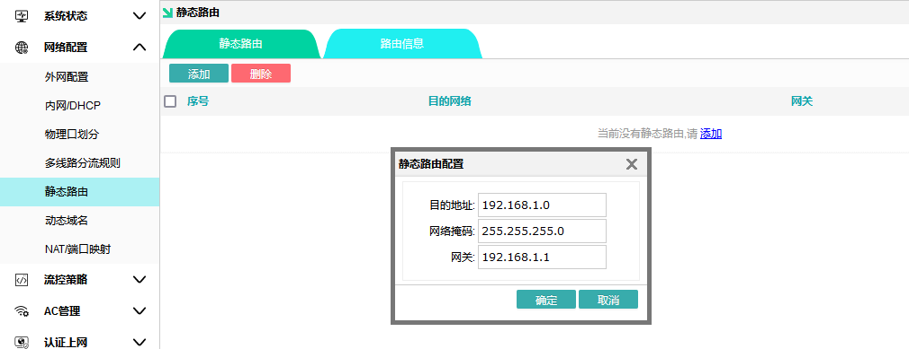

View Static Routing Table
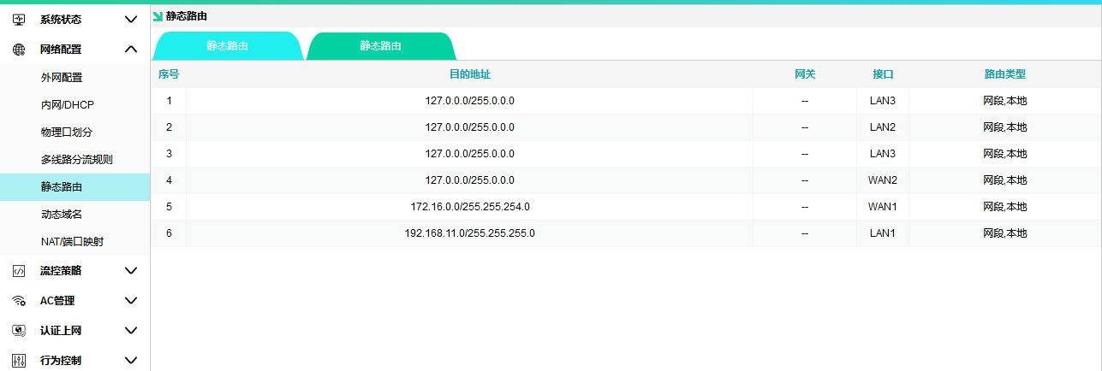

Dynamic Domain
Route management is performed from the external network by accessing the dynamic domain name, which is primarily provided by the dynamic domain service provider.
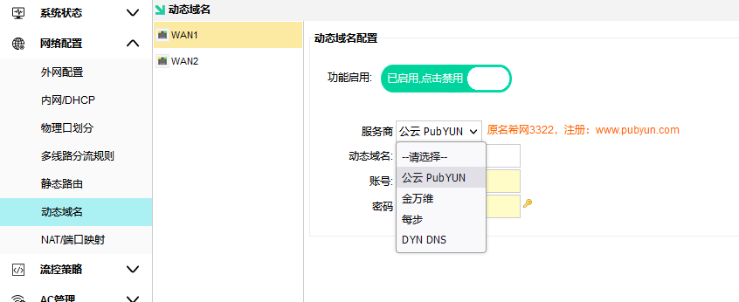
remarks ：

1. The router only handles IP reporting; the accuracy and speed of resolution depend on the 3322 service provider.
2. Some carriers assign internet IPs as local area network (LAN) addresses, such as 10.10.99.99, which are inaccessible from the external network. Configuring dynamic domain names on such LAN IPs is ineffective.

NAT/ port mapped
Used to map LAN ports to the public network
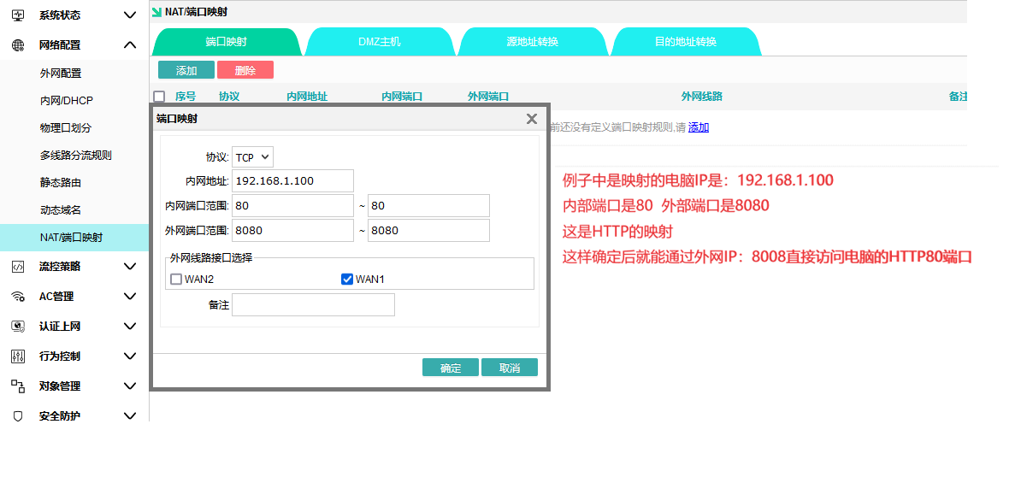

DMZ main engine
This feature addresses the issue where external networks cannot access internal network servers after installing a firewall. Click to enable the DMZ host 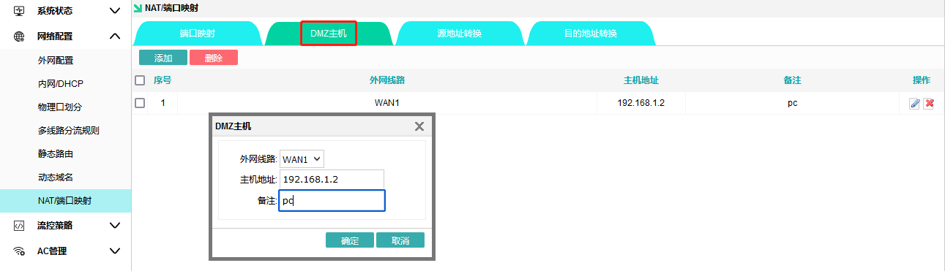and manually enter the address and external port to activate this function.

Source Address Conversion | Destination Address Conversion Source Address Conversion | Destination Address Conversion
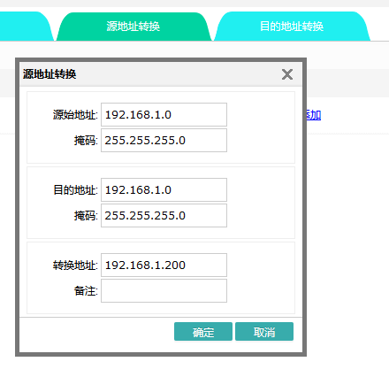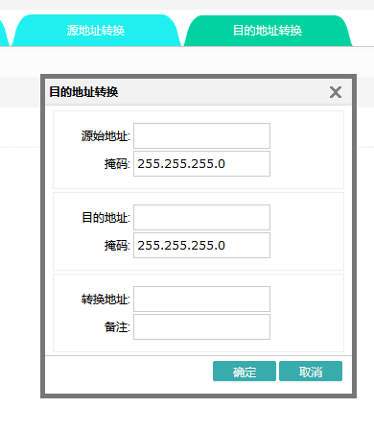

Flow Control Strategy
Manage the network speed of terminals by evenly distributing bandwidth or limiting terminal bandwidth.

Intelligent Flow Control
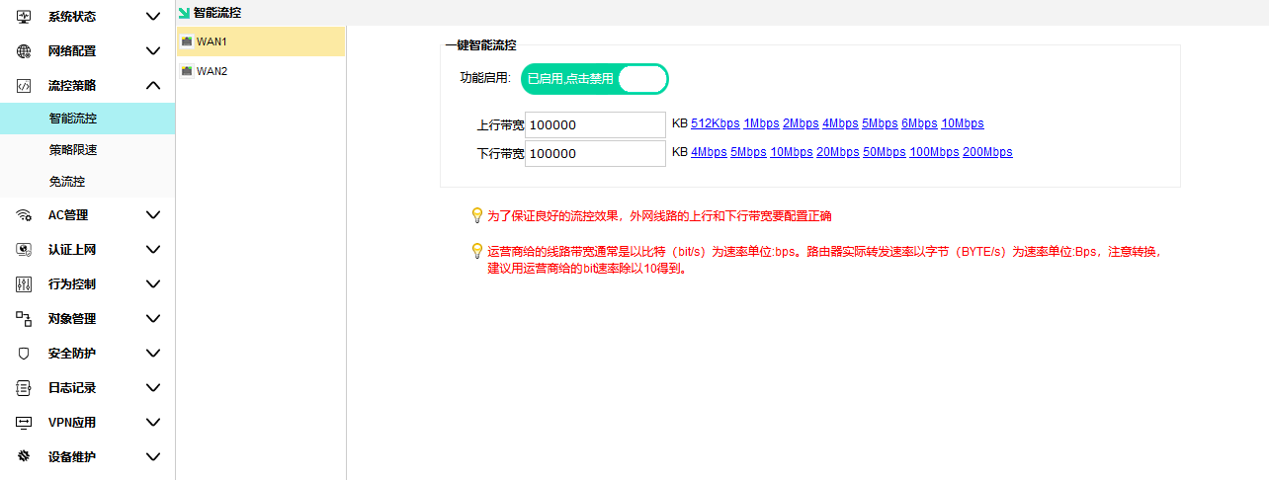
For example, a dial-up fiber with an upstream speed of 20 Mbit/s and a downstream speed of 100 Mbit/s can be configured with an upstream speed of 2000 KB/s and a downstream speed of 10000 KB/s. Configuring line bandwidth is crucial; Intelligent Flow Control automatically limits speeds based on the assigned bandwidth (the bandwidth configuration takes effect only if you check the "Enable Intelligent Flow Control" option).

Policy-based Speed Limit
Apply speed limits based on different source address rules
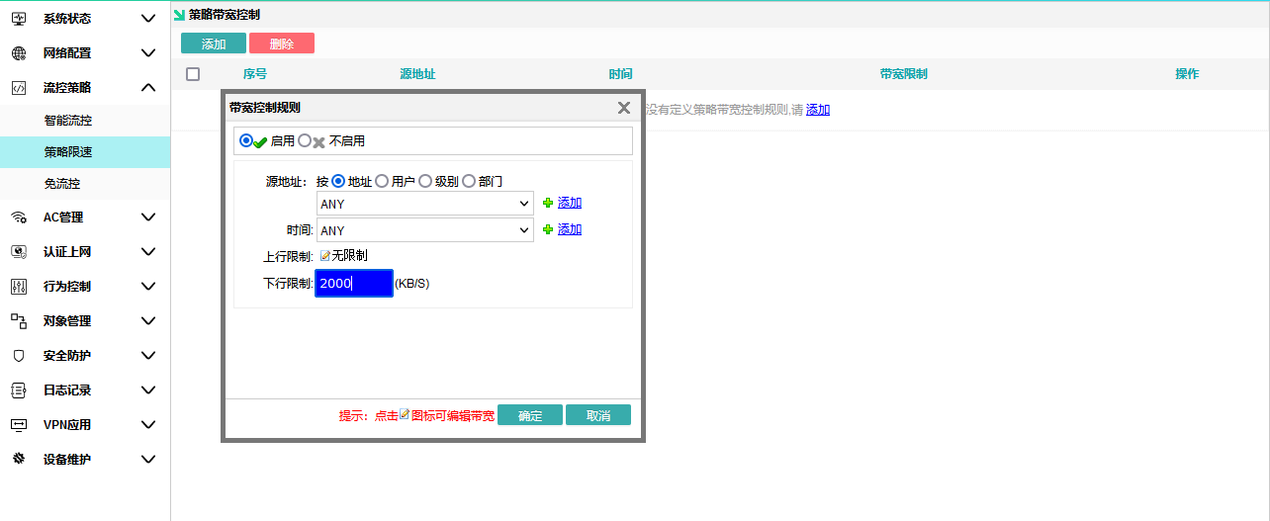

Free-flow control
Do not be constrained by the overall network speed control of intelligent flow management; instead, set a separate policy to limit its maximum bandwidth.
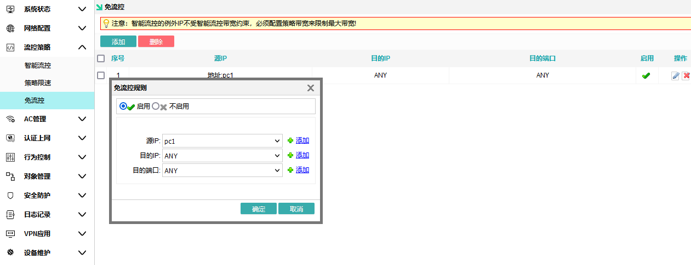

AC manage

AP Device List
Show all APs connected to the AC gateway for quick viewing and management.
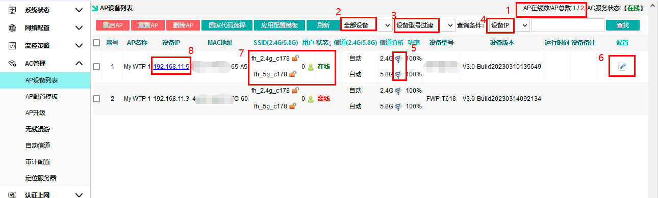
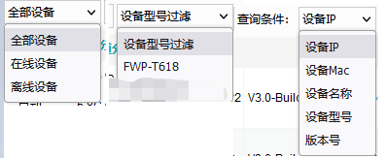
Number 1: View the number of deployed APs. Green indicates deployed APs, while red shows the total number of connected APs.
Number 2: Filter to display only online or offline APs.
Number 3: Filter to display only APs with a single model.
Number 4: You can search based on the AP device's IP address, MAC address, name, model, or version number.
No.5: WIFI Analyzer, used to scan all WIFI channels on this AP's 2.4 GHz or 5.8 GHz frequency bands.
Number 6: Edit parameters and configurations for a single AP.
Number 7: Displays the SSID (wireless WiFi name) and channel of the AP's 2.4G,5.8G, and 5.8G2 bands. Tap the green icon to connect a device to this AP.
Number 8: AP server login address.
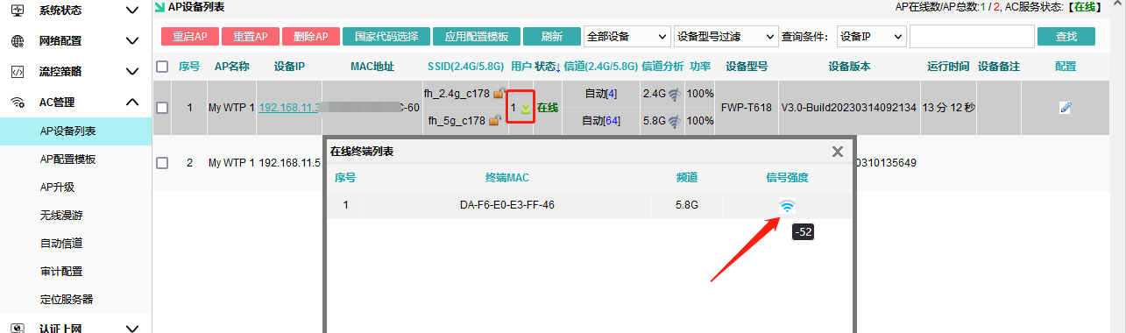

Click on the AP list to edit individual AP configurations on the right side
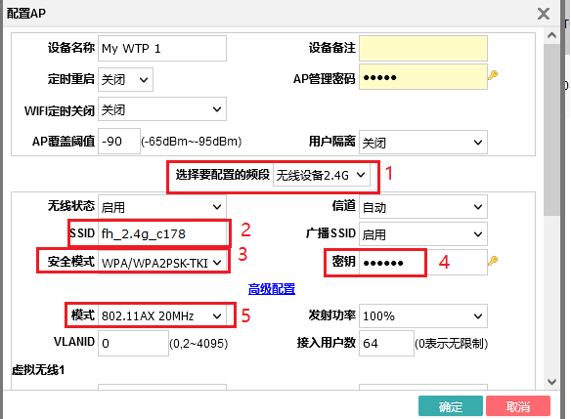
Main Editing Sections:
Number 1: Select parameters to edit for the current frequency band.
Number 2: Edit the WIFI name issued by AP.
Number 3: Encryption method – typically WPA2 PSK.
Number 4: Edit your WIFI password. Click the lock button on the right to view it.
Number 5: Select a protocol mode with a different current frequency band.
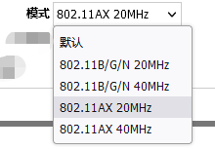
Secondary Sections:
Device Name, Device Note: Used to distinguish all locations of this AP; the note can typically be set as installation location or coverage location.
timed restart: Set this AP to automatically restart at a specific time each day or every 1–10 days.
AP Management Password: The login password for this AP's management page.
Wireless Status: Select this frequency band to enable or disable it.
Channel: You can choose automatic channel selection, where the AP will automatically find the optimal channel, or manually select a specific channel.
Broadcast SSID: Activated, the device can be searched; disabled, the SSID is hidden.
User isolation: Controls whether terminals under this AP can access each other.
Transmission Power: Default is 100%; available options include 75%,50%,25%, and 12%.
AP Coverage Threshold: If the detected terminal's connection strength falls below the threshold, the AP will exclude it.
VLAN ID: Sets the ID for the AP wireless service VLAN.
Number of connected users: Maximum number of devices connected to this AP.
Virtual Wi-Fi: Create up to 3 virtual Wi-Fi networks per frequency band, each with a unique SSID and password.
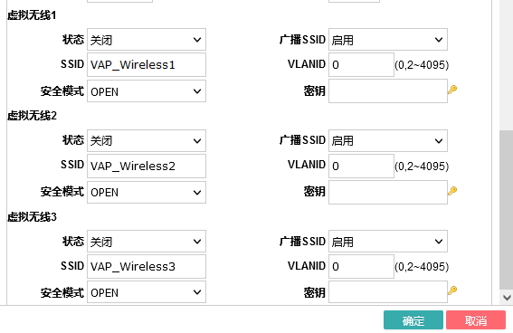

AP Configuration Template
Select a model to add a template; each model corresponds to one template. Configure the SSID and password, then select all APs of the same model in the AP list and choose the corresponding template from Application Configuration.
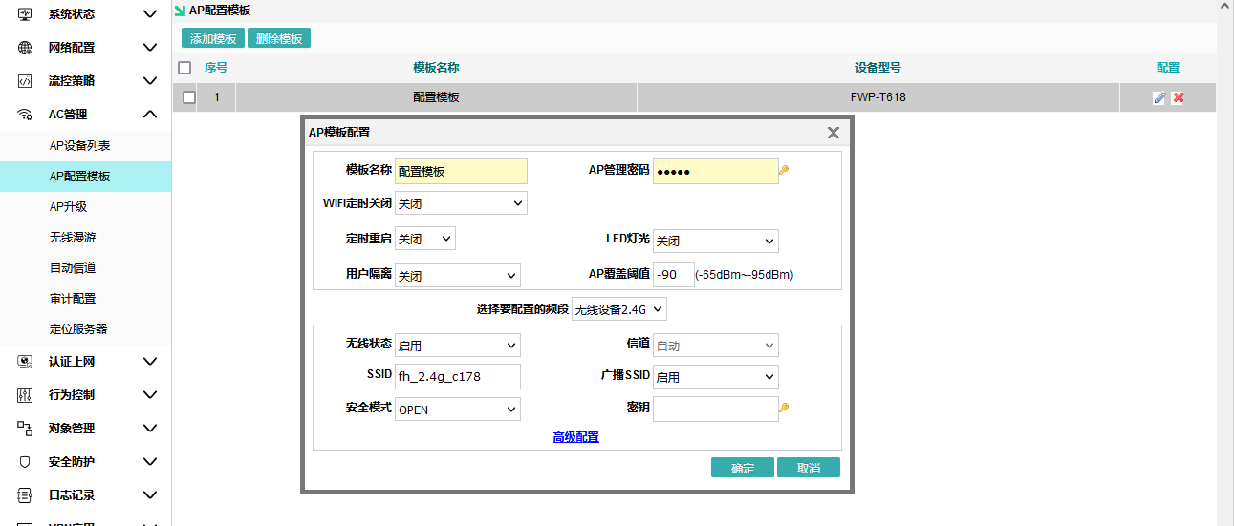

AP upgrade
You can choose online upgrade or upload firmware for local upgrade.
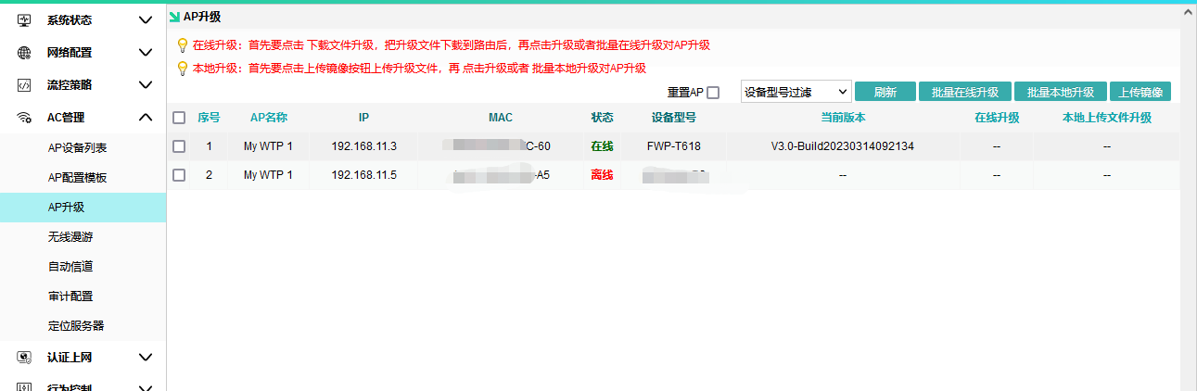

Seamless roaming
KVR Switching Threshold Configuration
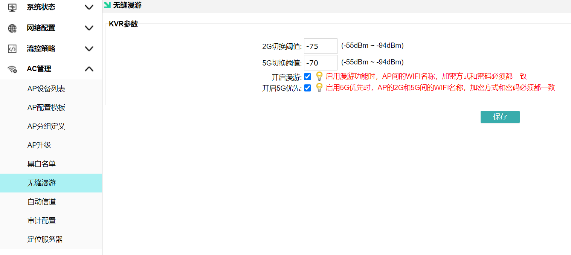

Automatic Channel
Configure the timing for re-scheduling and re-channeling coordination
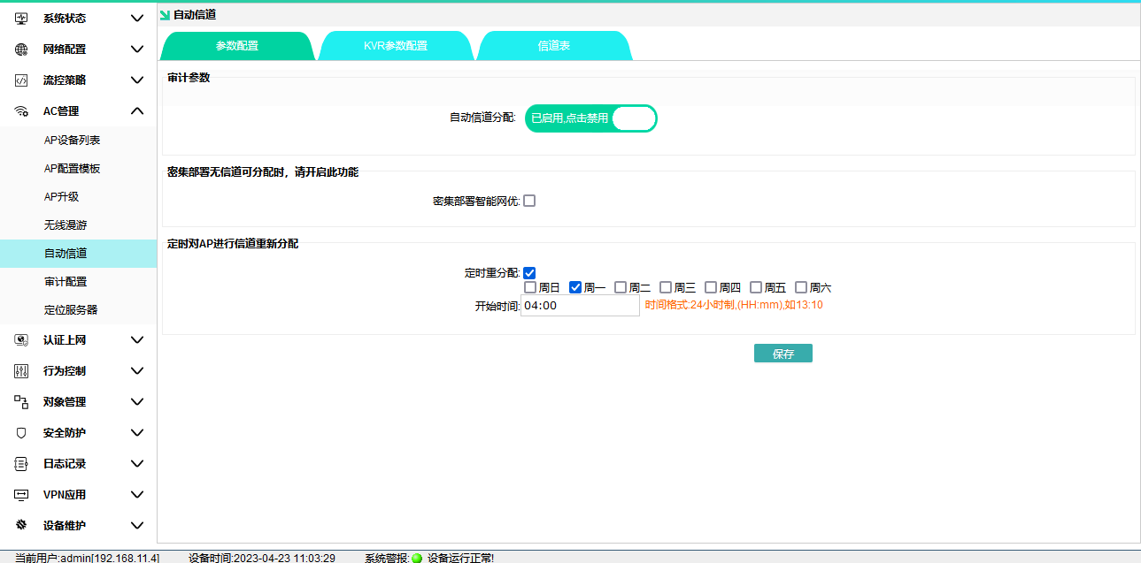

Channel table: View the channels and signal strength of other Wi-Fi networks for each AP.
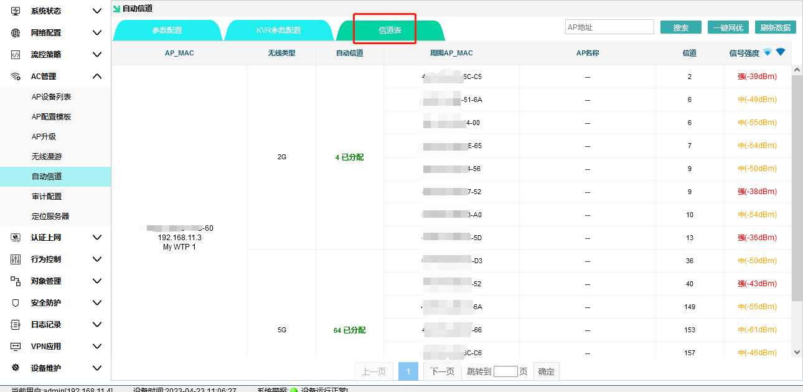

Audit Configuration and Server Location
For custom development integration with the audit system
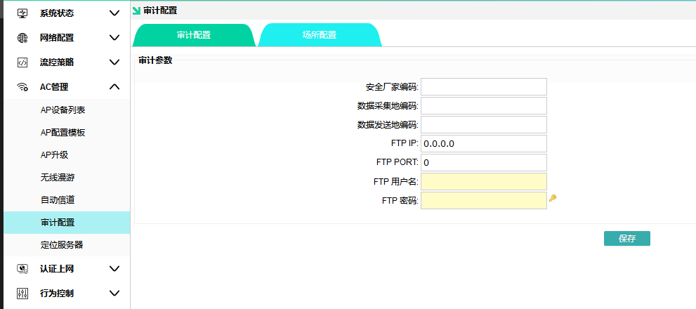
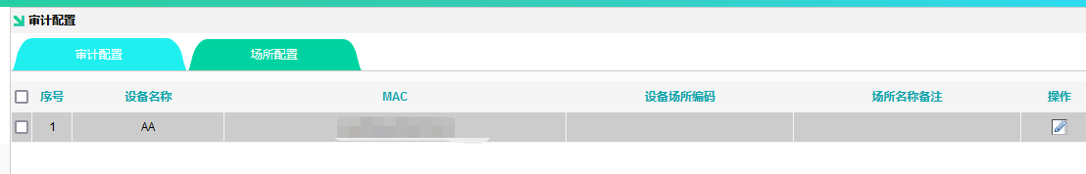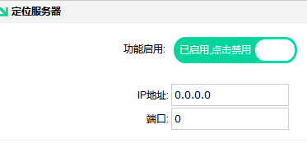

Certified Internet Access
Typically, internet users can obtain an IP address by configuring the network card's IP address or letting the router assign one via DHCP, allowing direct internet access.

authenticated internet access means that a user identity is required to access the internet.

Authentication Configuration
Control the authentication switch for the corresponding LNA port.
Note: Activating any of these switches blocks traffic on LAN 2. Only authenticated users are allowed to access the internet.
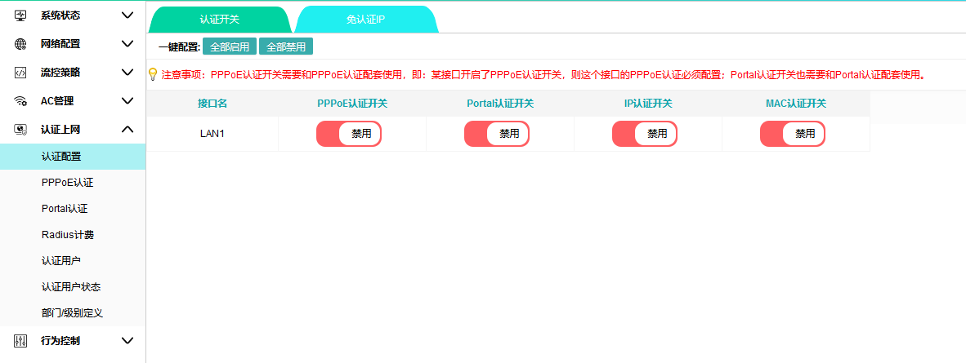

PPPoE attestation
PPPoE authentication – Used for community broadband, where internal network users access the internet via PPPoE dial-up. The dial-up credentials (username and password) are configured on the router (if connected to a Radius billing system, they must be set up in that system).
For address pool allocation, it is recommended to use a LAN address that does not belong to the same subnet as the LAN port's IP address. For example, if the LAN port's IP address is 192.168.1.1, the address pool cannot be 192.168.1.xxx.
DNS recommends using the local carrier's DNS.
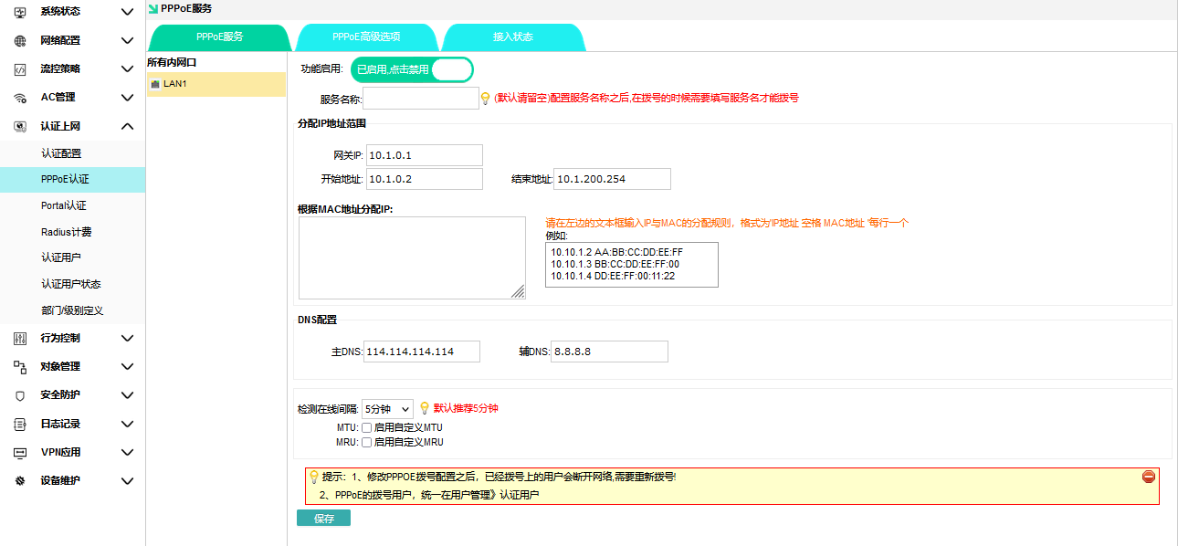
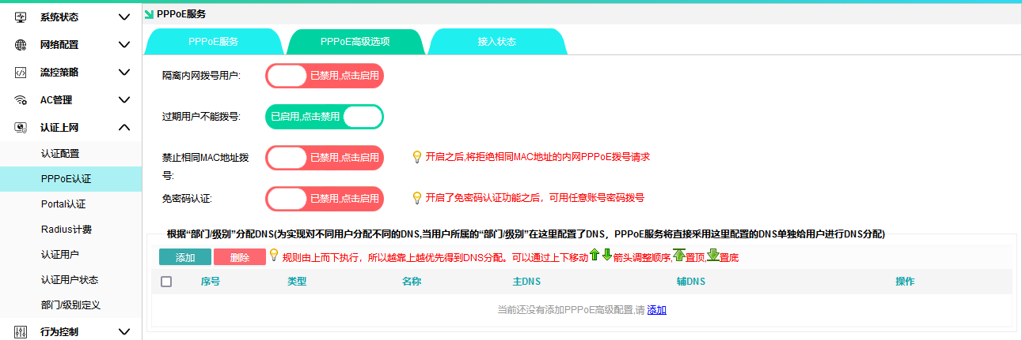

Portal attestation
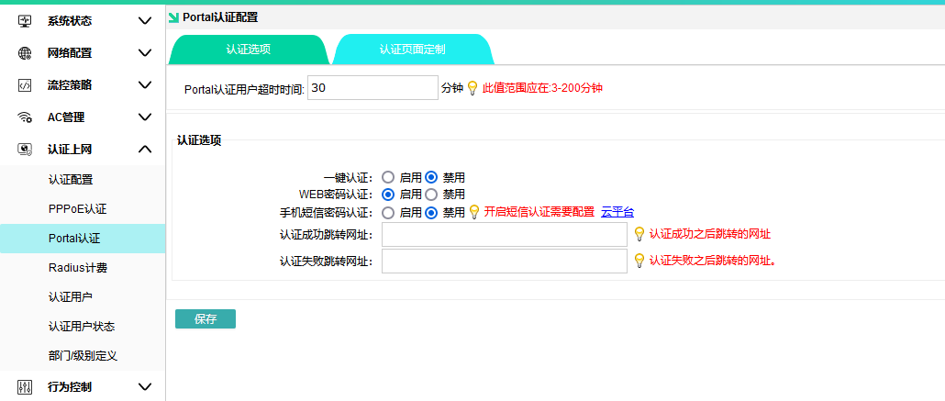
One-click authentication: Used in hotels and guesthouses to prevent camera holes from connecting to WiFi. Requires an additional manual click step, equivalent to self-service approval.
WEB Password Authentication: Users connected to the router (e.g., smartphones) log in by entering their username and password in the pop-up authentication window. The WEB password account credentials are created on the router (if integrated with Radius billing, creation is required in the Radius billing system).
SMS Authentication (Paid): Enter your phone number to receive a random code from the SMS platform for online authentication.

Authentication Page Customization: Customize upload image assets
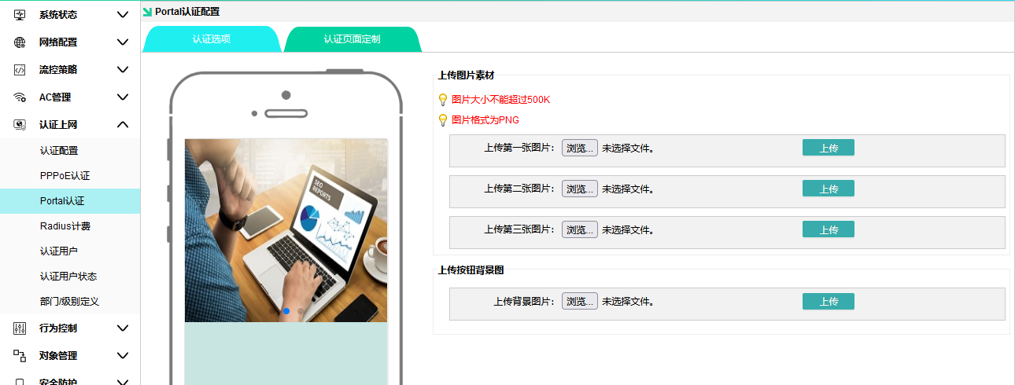

Radius charging

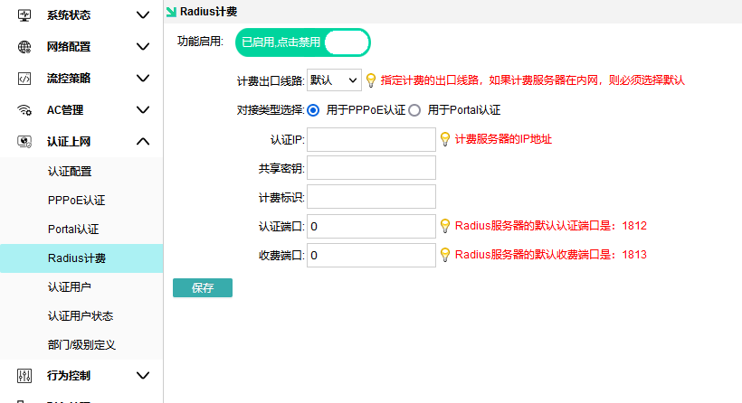

Authenticating User
The figure below shows four types of users.
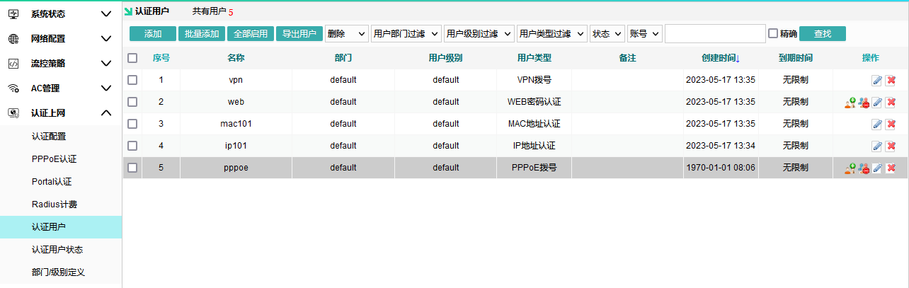
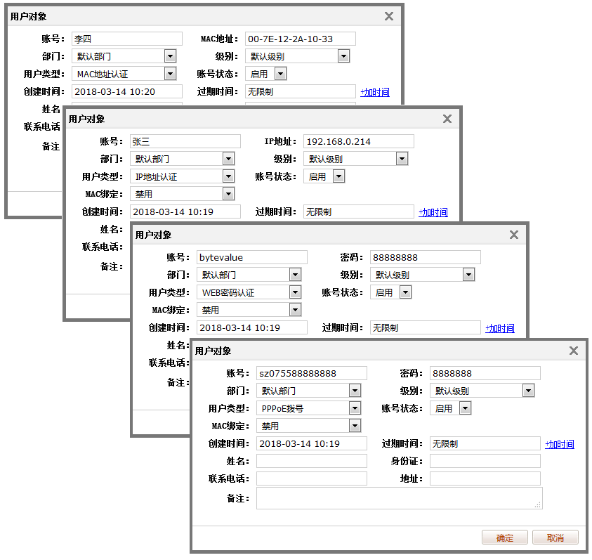

Authenticate User Status
You can see active users; the green icons in the image represent them.
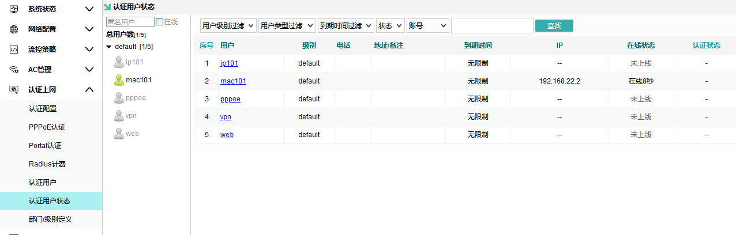

Department/Level Definition
Department Division: Manages departments and levels to associate internet users
Department Classification Purpose: Users must be assigned to a specific department; therefore, departments need to be defined before creating users. For companies, departments are typically organized by administrative divisions (e.g., Sales Department, Production Department). For residential communities, departments are usually established based on user locations (e.g., Building 35 East, Building 88 West). Once departments are defined, users can be subject to various control rules corresponding to their assigned department.
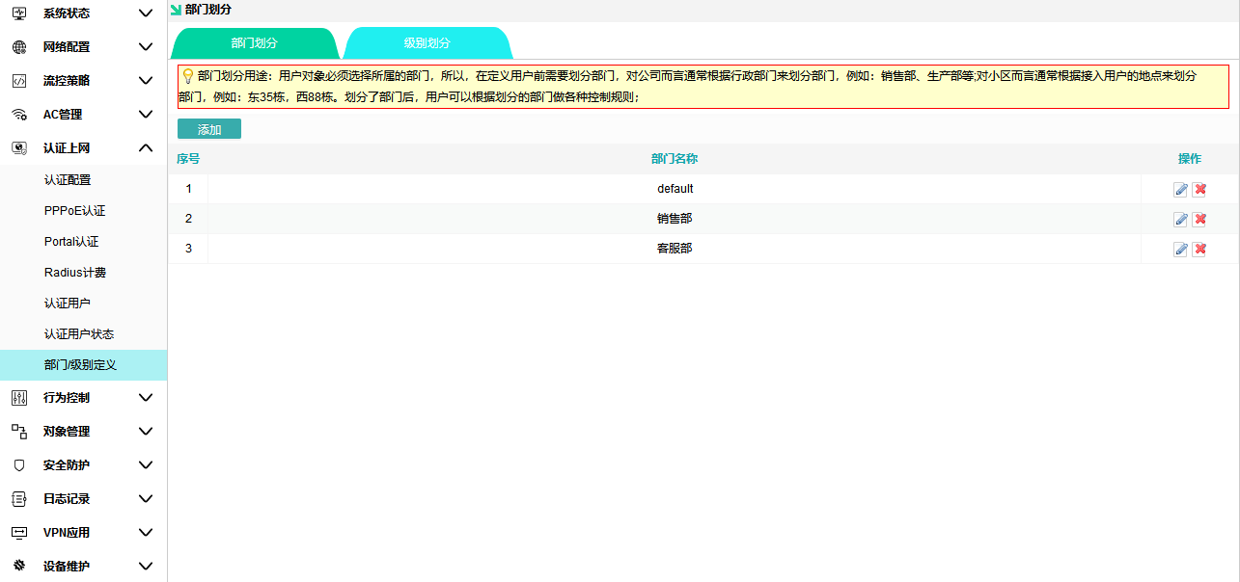

Purpose of Level Classification: Users must select their appropriate level; therefore, levels need to be defined before creating users. For organizations, levels are typically assigned based on user permissions and roles (e.g., senior executives, regular employees). For residential communities, levels are usually determined by the purchased bandwidth (e.g., 2M,4M). Once levels are defined, various control measures or speed-limiting rules can be applied accordingly.

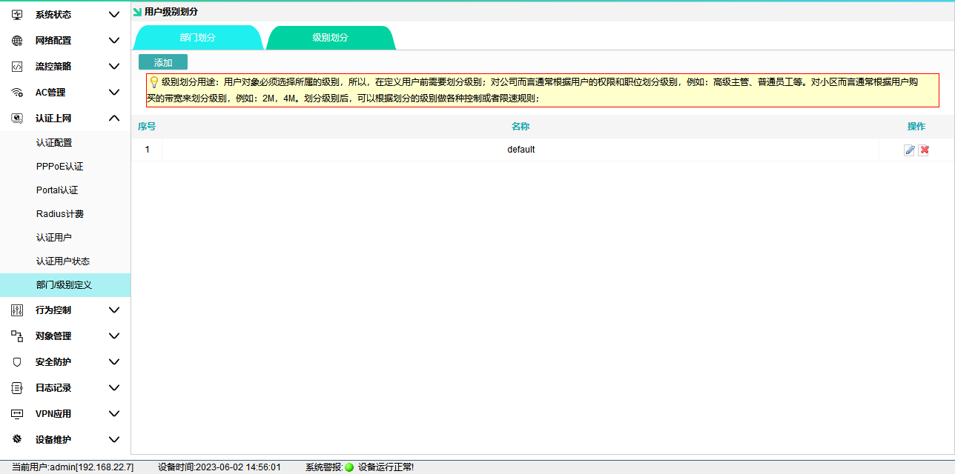

behavior control

Apply Firewall
Configure the target IP, port, and application for permitted or directly blocked access based on source and time settings.
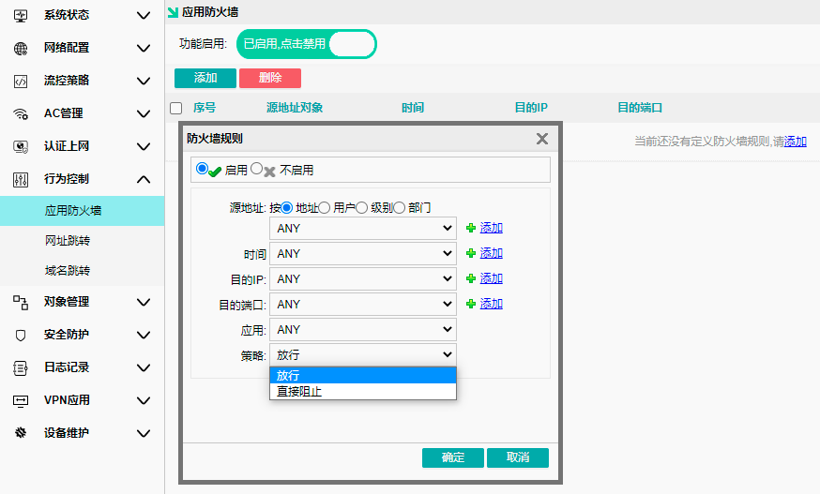

URL Redirection
Set to automatically redirect to the destination URL when the terminal accesses the original URL (effective after clearing browser cache).
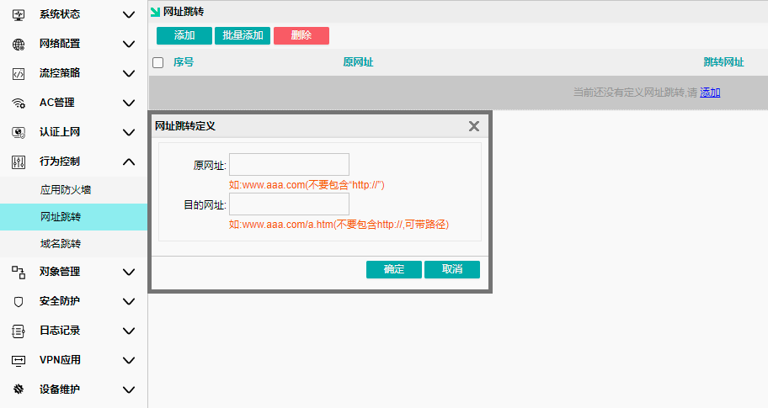

Domain Redirection
Set the terminal to automatically resolve domain names to specified IPs when accessing them (effective after clearing browser cache)
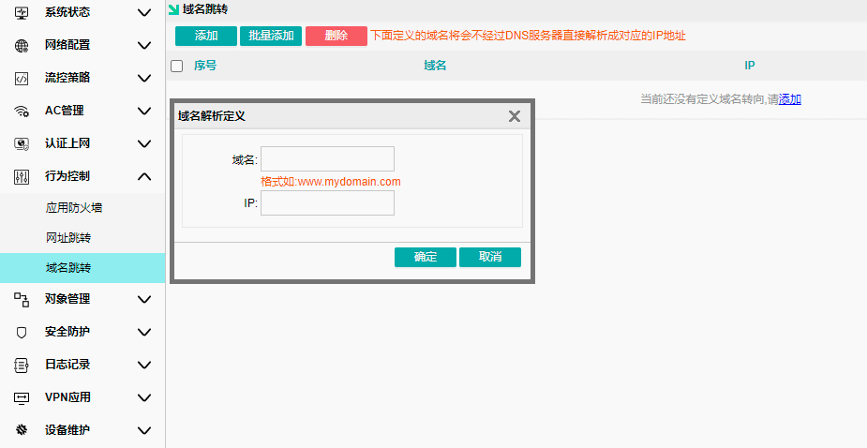

Object Management

Basic Object – Time Object
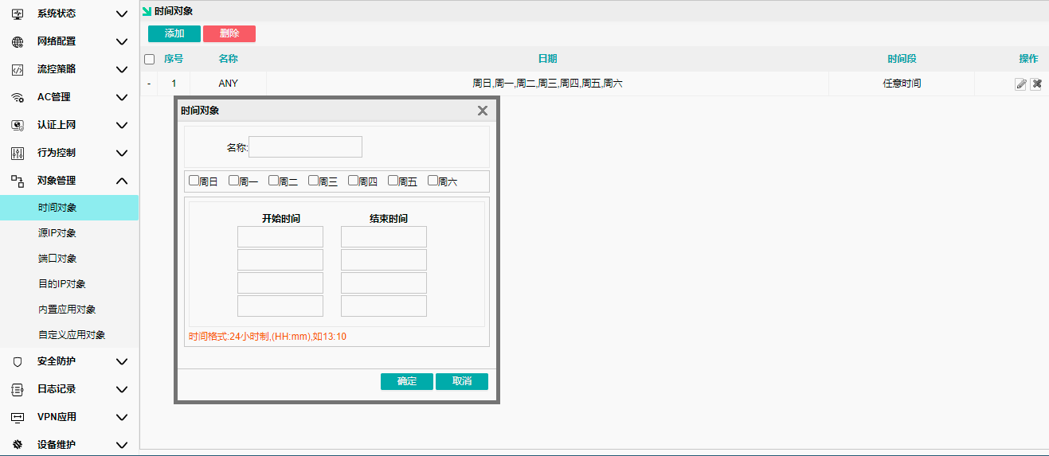

Basic Object – Source IP Object
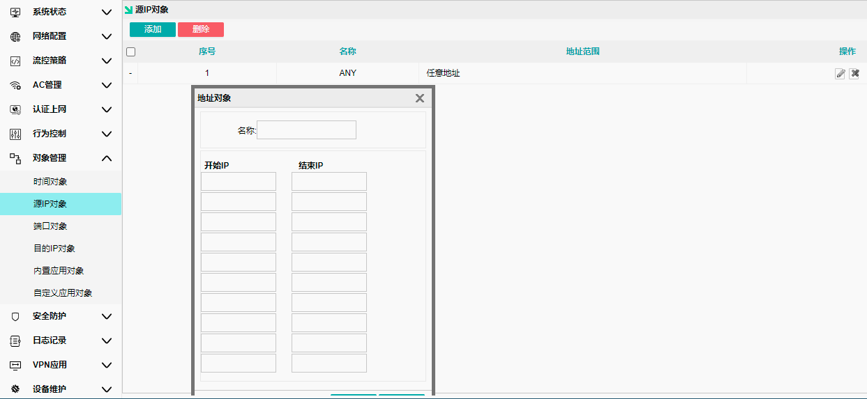

Basic Object – Port Object
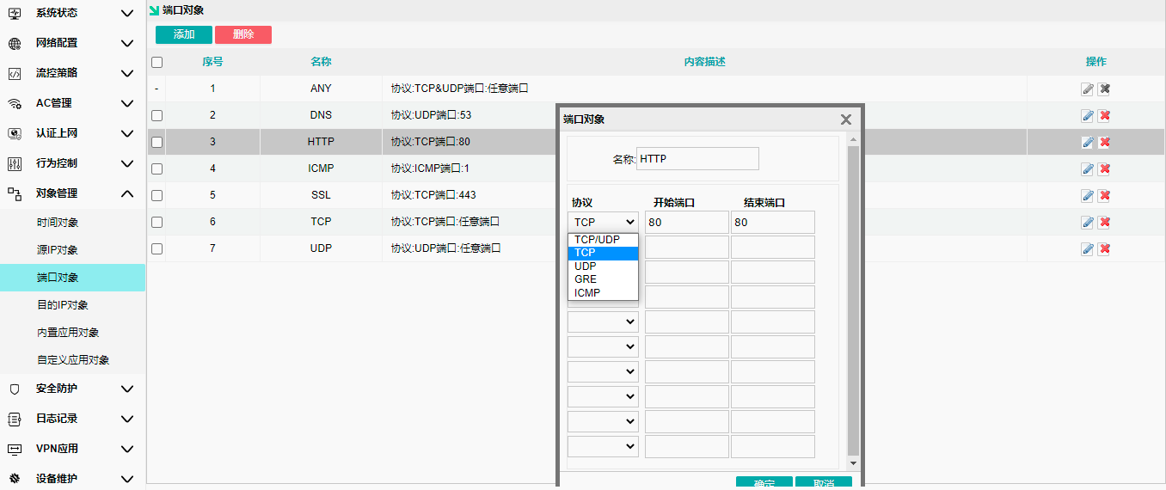

Basic Object – Destination IP Object

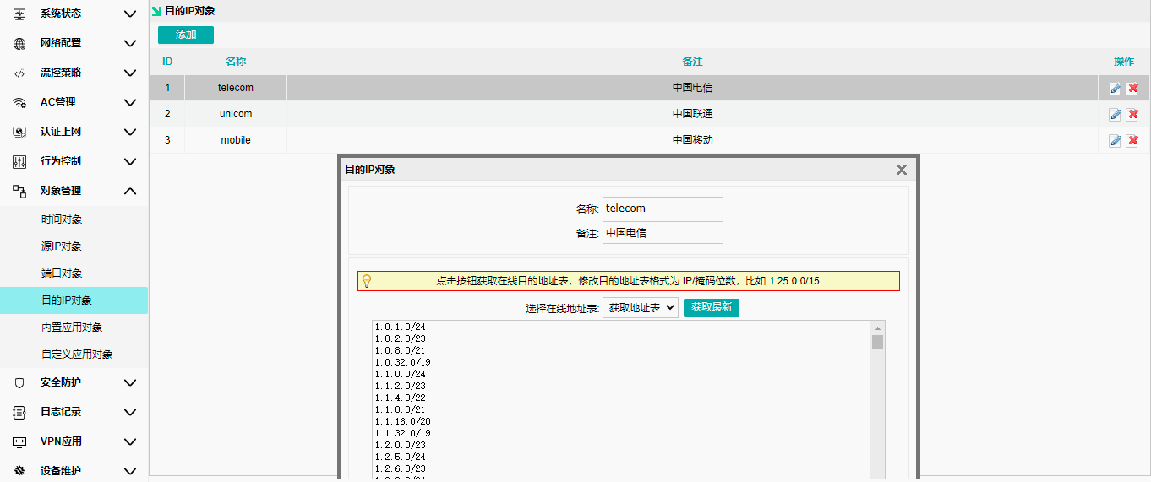

Application Object – Built-in Application Object
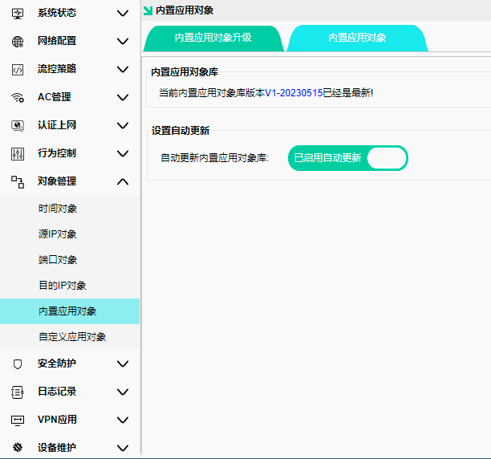
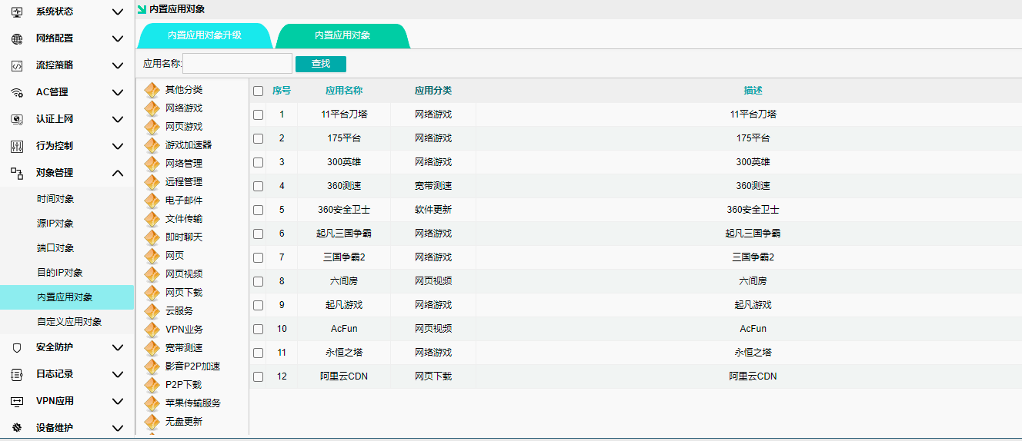

Application Object – Custom Application Object
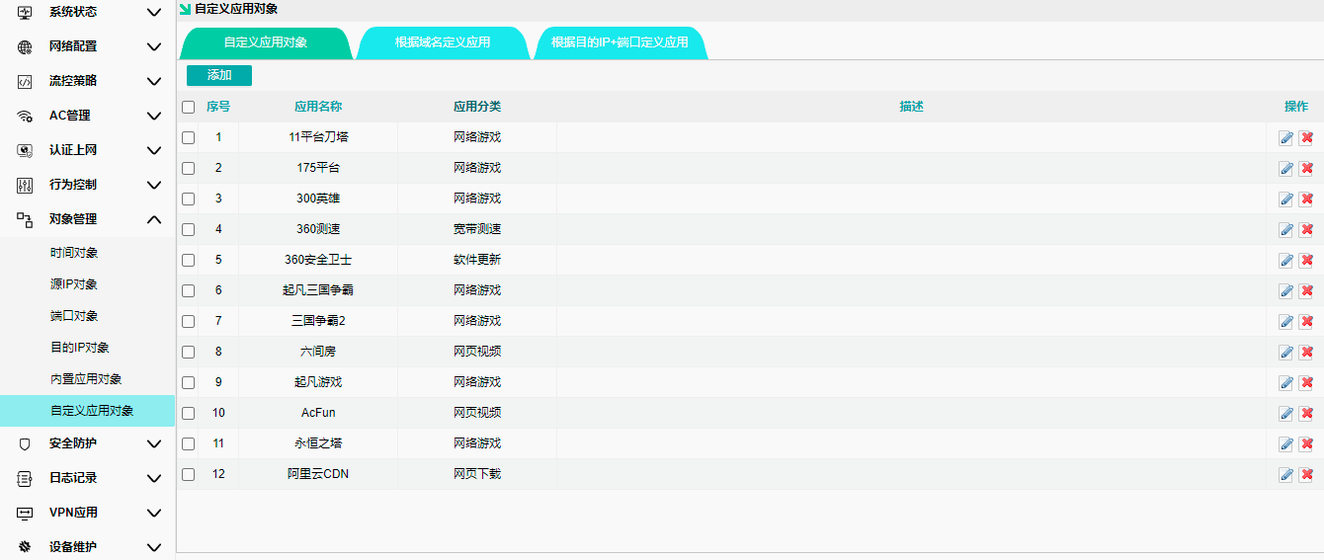

Apply based on domain definition
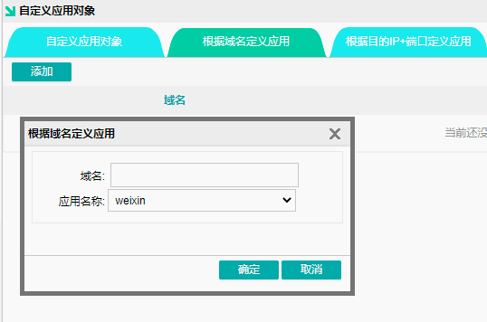
Define applications by destination IP and port
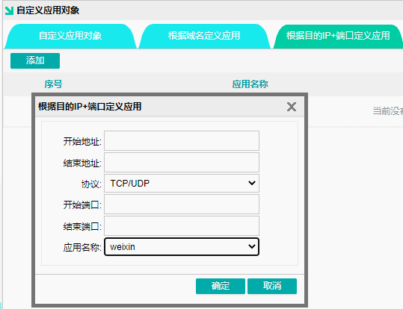

safe guarding

IP-MAC binding
After binding IP-MAC, the inability to arbitrarily modify IP addresses prevents IP conflicts that could disrupt other users' normal internet access.
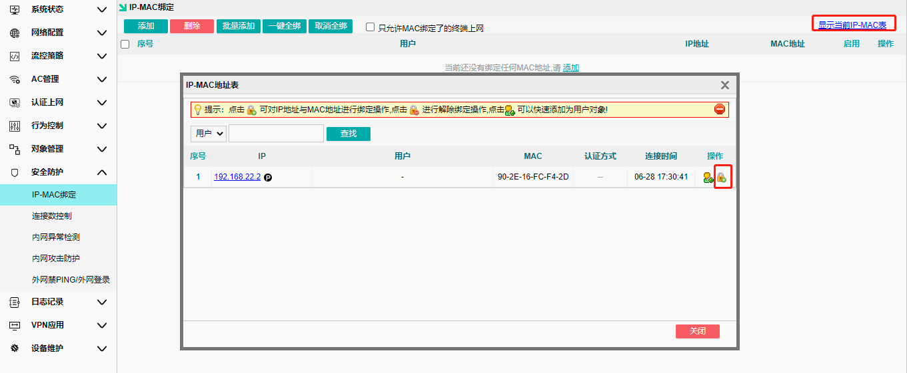

Connection Count Control
Limit the maximum number of TCP and UDP connections for the source object
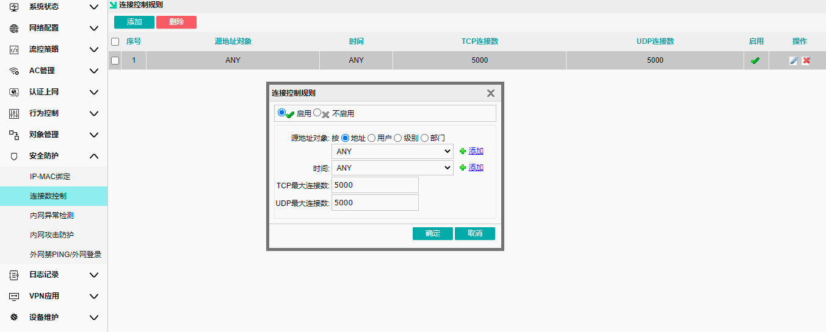

Internal Network Abnormality Detection
Enabling DHCP detection allows you to check for other DHCP servers on the local network that may cause IP address conflicts.
It is normal for an AC gateway to detect the primary router as its own when acting as a secondary router.
Enabling loop detection helps identify whether switches in a local network have link loops, which can cause broadcast storms and result in slow, unstable internet performance.
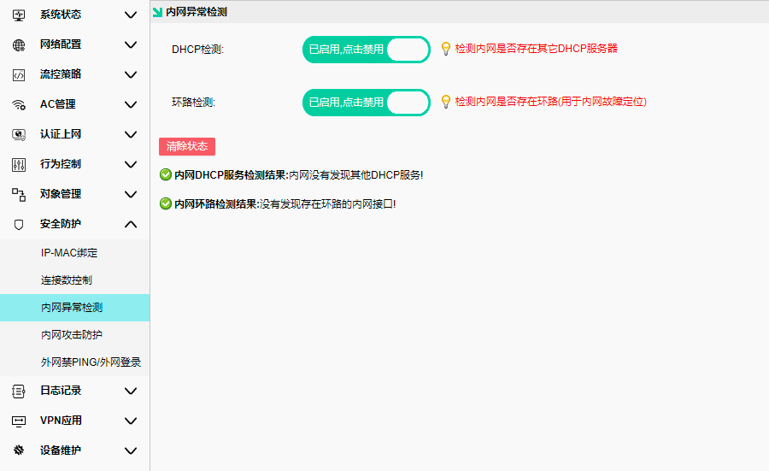

Common examples:
A private third-party router is connected to the LAN port, resulting in a DHCP conflict when improperly connected to the router's LAN port.
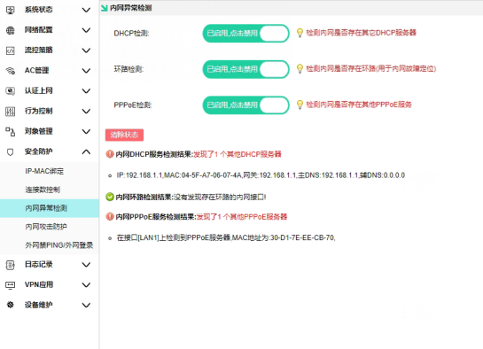

Internal Network Attack Protection
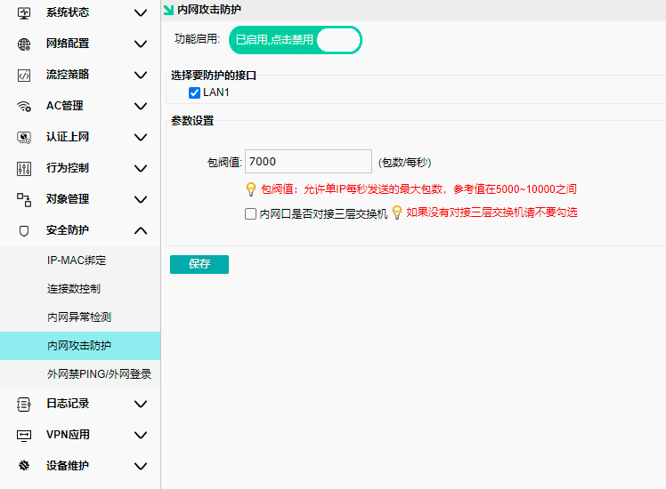

Ping is prohibited on the external network / Login to the external network
View remote login parameters and configurations
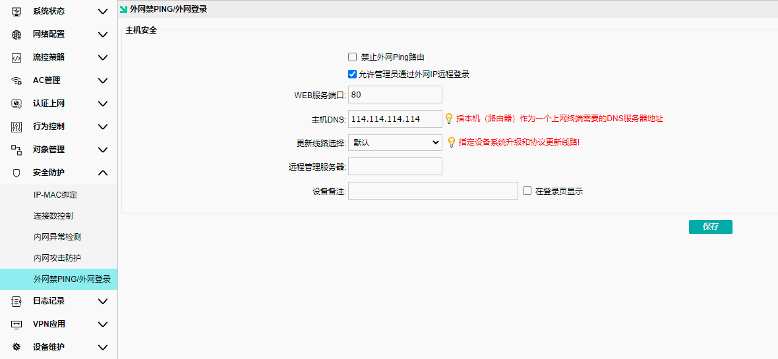

Log Record

User Authentication Log
Check device online and offline status
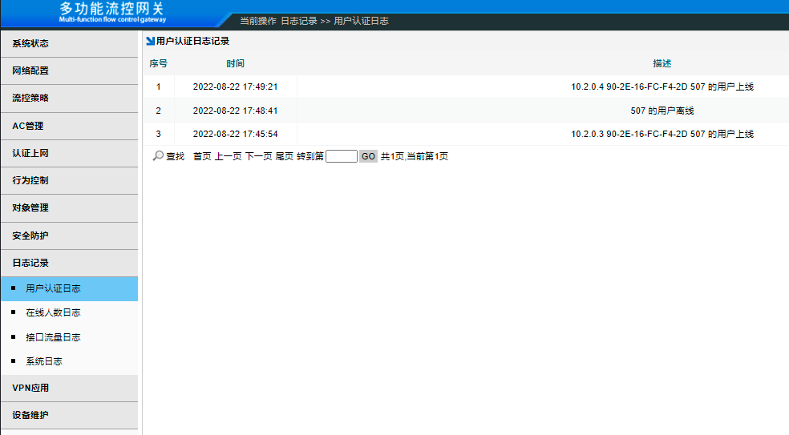

Online User Count Log
Add the endpoint as a user object for recording
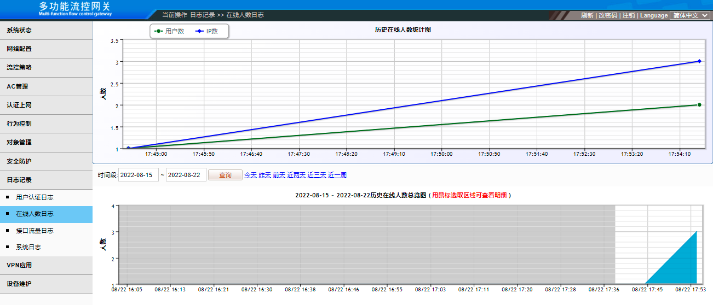

Interface Traffic Log
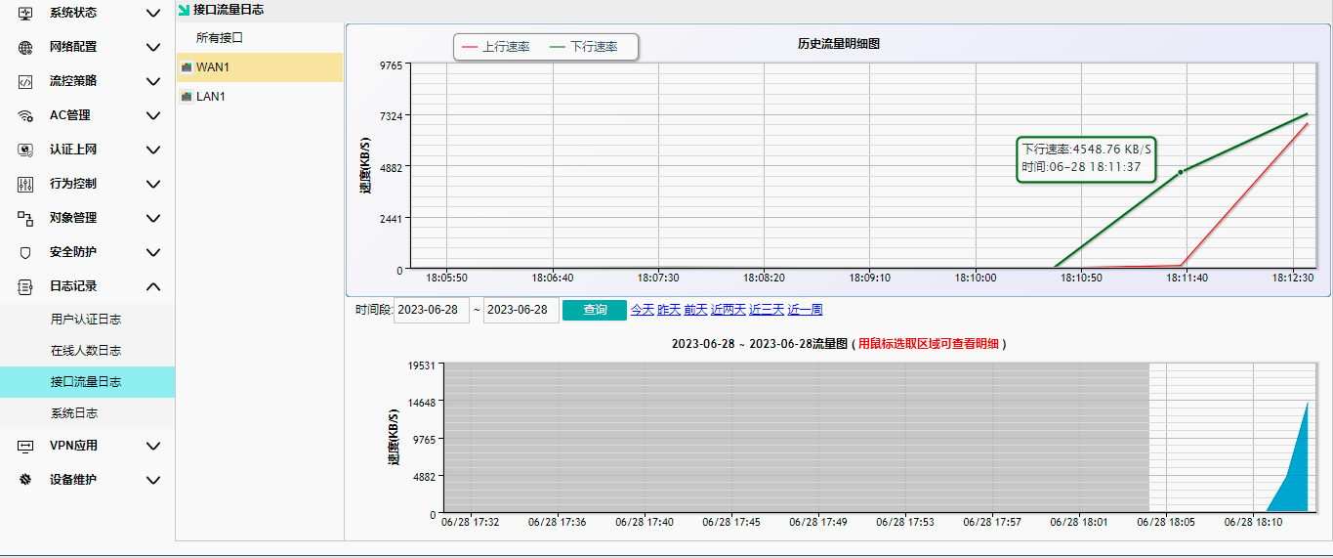

system log
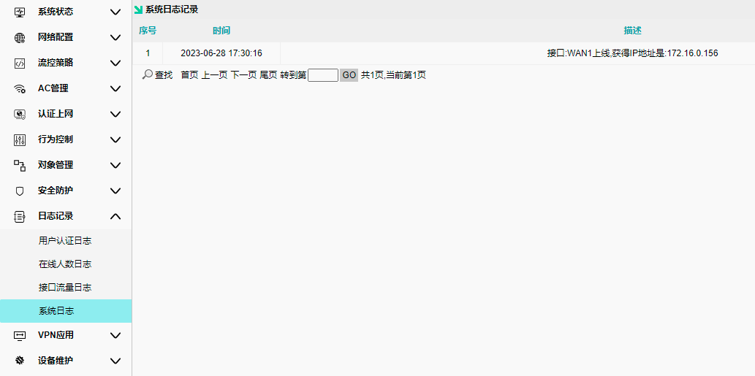

VPN apply

PPTP
To use this feature, the AC must serve as the primary router, and its WAN port must be connected to a public IP address provided by the carrier.
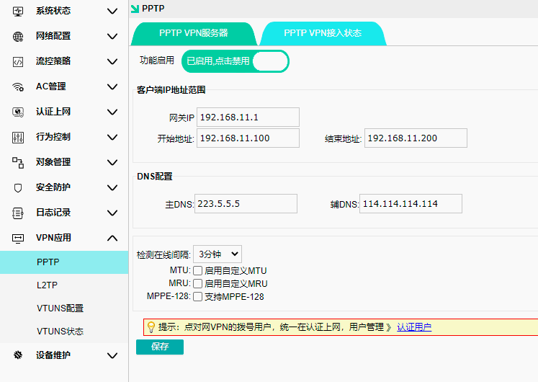
The gateway IP and address pool should be configured according to actual DNS requirements.

Click to authenticate users and proceed to create a VPN authenticated user
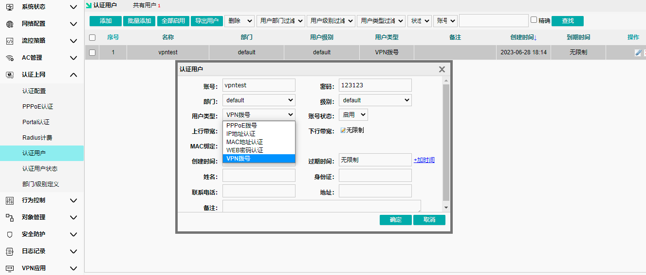

L2TP
To use this feature, the AC must serve as the primary router, and its WAN port must be connected to a public IP address provided by the carrier.
The gateway IP and address pool should be configured according to actual DNS requirements.
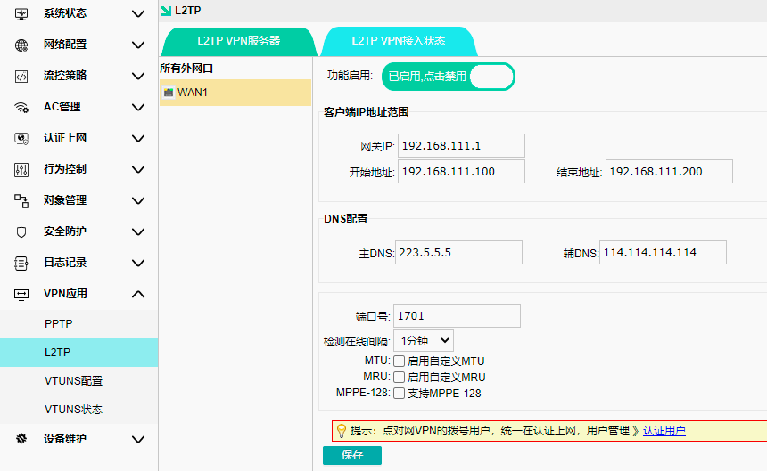

VTUNS
The network establishes a virtual channel over TCP/IP between two local area networks for integration. The higher-performance network segment serves as the server, with both segments having distinct IP addresses; the server must possess a public IP address.

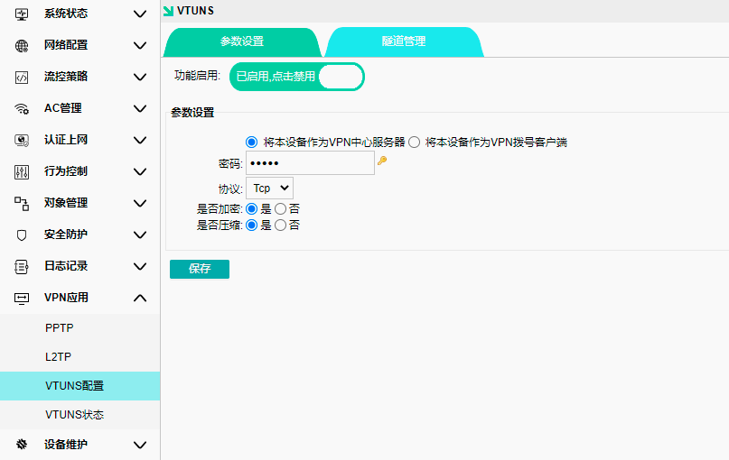
Tunnel management: Add custom tunnel names and IDs, and specify the internal network segment for the VPN client (e.g., 192.168.1.0 with mask 255.255.255.0). Note that tunnel names and IDs must match exactly between the server and client configurations.
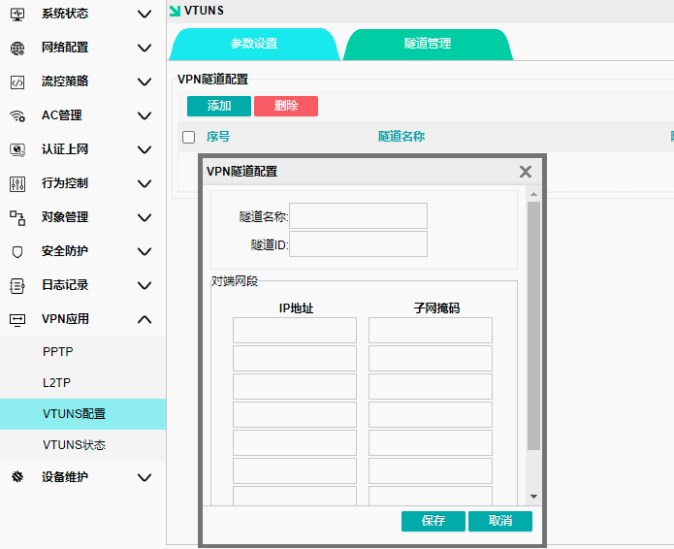

plant maintenance

Device Upgrade
Upgrade online or select a specific firmware upgrade
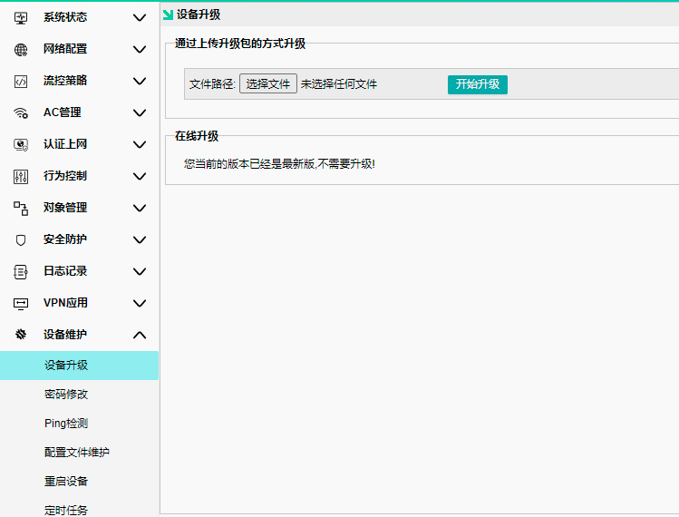

Change Password
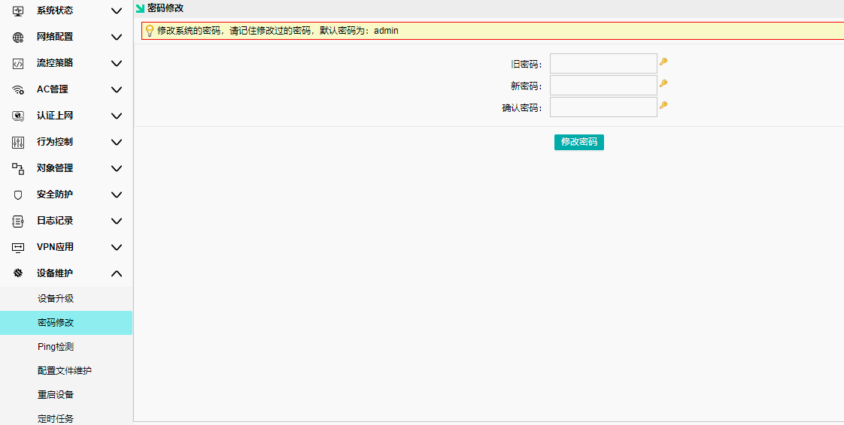

Ping check
Check whether a path exists between AC and the specified IP.
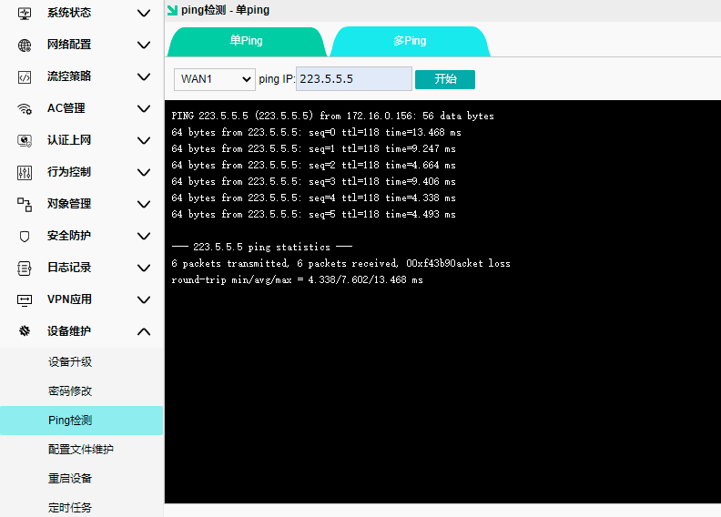

Multiple Ping
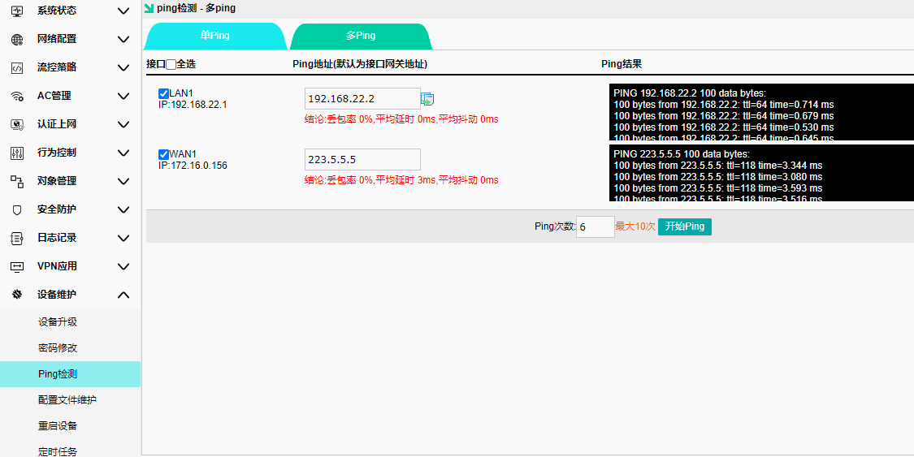

Configuration File Maintenance
Used to export and import gateway configuration information, and restore it to factory settings
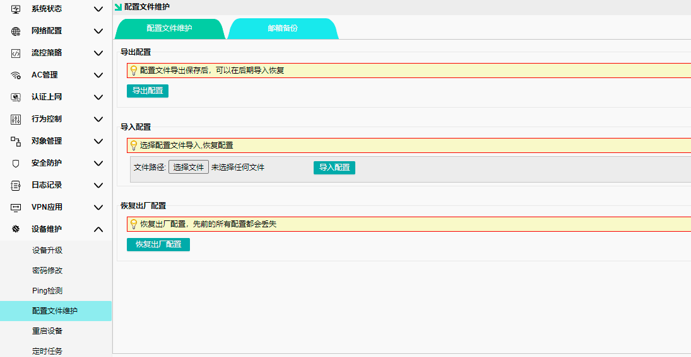
Mail Backup: Enter the sender and recipient email addresses to periodically collect backup files
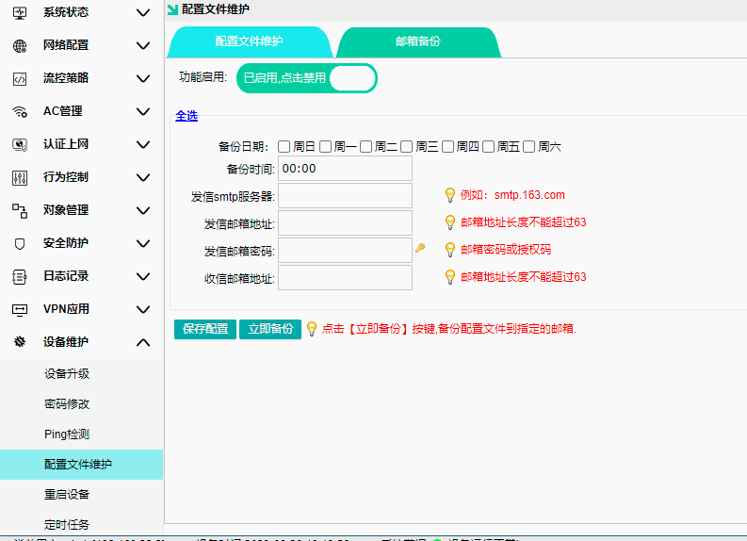

Reboot the device
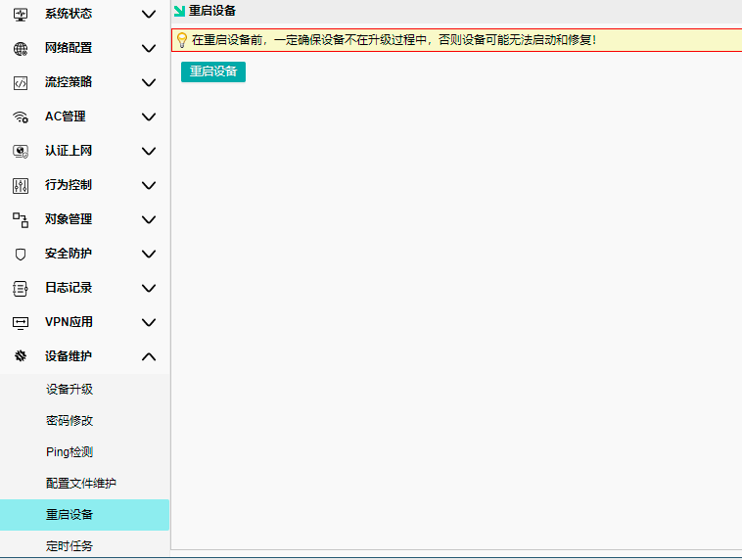

timed task
Set up the gateway's scheduled operation
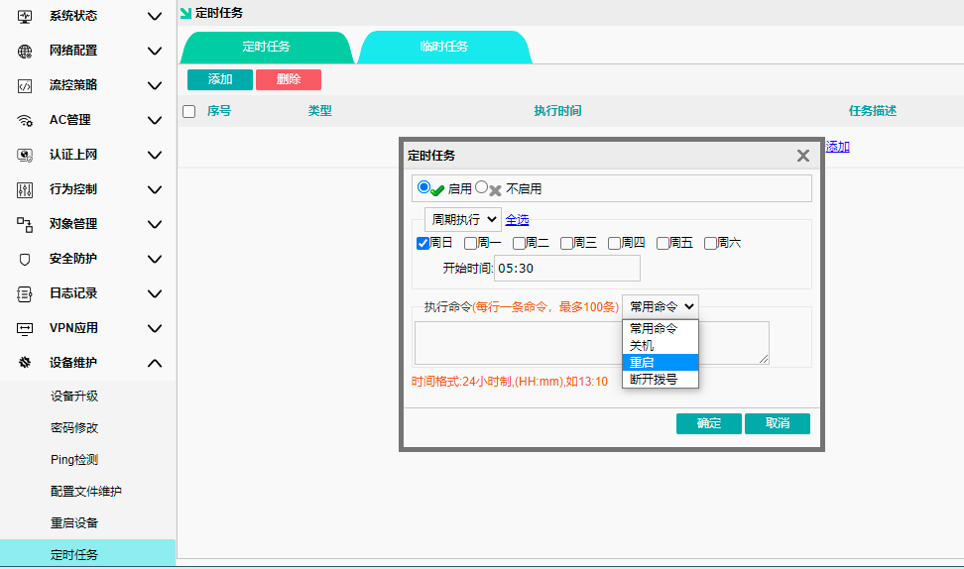

time lock
You can select different time zones and primary time servers
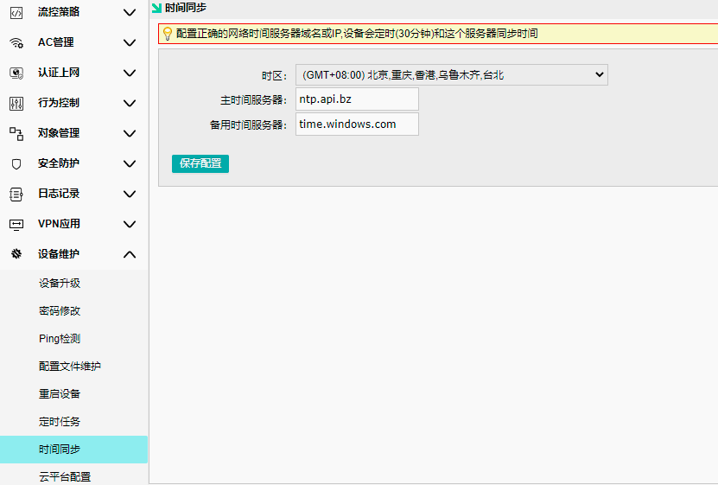

Cloud Platform Configuration
AC is bound to the cloud platform, allowing remote management of both AC and AP.
Enter the cloud platform address, register an account on the platform, and after logging in, enter the AC's LAN port MAC address to bind it.
