LBTD48G-SFP

8-port 10/100/1000BASE-TX+4-port SFP Industrial Ethernet Switch
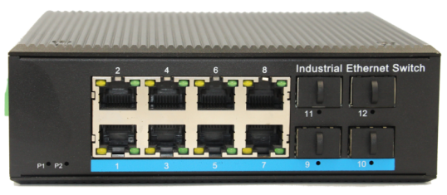
Interface
- 8-Port 10/100/1000Base-Tx RJ-45 with auto negotiation and auto-MDI/ MDI-X function
- 4-Port SFP

Industrial conformance
- 12V to 52V DC, redundant power input
- -40℃ to 80℃ operating temperature
- IP40 aluminum housing
- Supports 6KV DC Ethernet ESD protection
- Supports 6KV DC EFT protection for power line
- Free Fall, Shock and Vibration Stability
- DIN-rail design

LBTD48G-SFP an hardened 12-port Industrial Ethernet Switch, provides non-blocking wire-speed performance in harsh industrial environment. It also provides 8-port 10/100/1000BASE-TX RJ45 +4-port SFP delivered in an IP40 rugged, strong case with redundant power system. Its slim case is suitable for such applications as surveillance system deployments, control management and wireless service in climatically demanding environments with wide temperature range from -40℃ to 80℃.

The LBTD48G-SFP provides the flexibility to all kinds of 10/100/1000Mbps Ethernet Media on RJ-45 port and performs highly stable fiber performance.

Specifications:
ROBOT
ROBOT
Model No. | LBTD48G-SFP
10/100/1000Base-TX Port | 8 port RJ-45 auto-MDI / MDI-X
1000Base-FX Port | 4 port SFP
Performance Specification | Bandwidth: 52Gbps  Packet Buffer Memory:2Mbit  Packet Forwarding Rate:41.7Mpps  MAC Address Table: 8K
Installation | DIN rail
Maximum Frame Size | 9000bytes packet size
Flow Control | Back pressure for half duplex, IEEE 802.3x pause frame for full duplex
Enclosure | IP40 aluminum housing
LED Indicator | Power: Red  Fiber: Green  Ethernet: Yellow
Power Input | 12 to 52V DC redundant power
Power Consumption | < 10 watts
Surge protection | ±4KV
Network Protocols | IEEE802.3 10BASE-T;  IEEE802.3i 10Base-T;  IEEE802.3u;100Base-TX/FX;  IEEE802.3ab 1000Base-T;  IEEE802.3z 1000Base-X;  IEEE802.3x;
Network cables | 10BASE-T: Cat3,4,5 UTP(≤100 meter)  100BASE-TX: Cat5 or later UTP(≤100 meter)  1000BASE-TX: Cat6 or later UTP(≤100 meter)
Industry Standard | FCC CFR47 Part 15,EN55032, Class A  IEC61000-4-2 (ESD): ±8kV (contact), ±12kV (air)  IEC61000-4-3 (RS): 10V/m (80~1000MHz)  IEC61000-4-5 (Surge): Power Port: ±2kV/DM, ±4kV/CM; Data Port: ±2kV  IEC61000-4-6 (CS): 3V (10kHz-150kHz); 10V (150kHz-80MHz)  IEC61000-4-16 (Common mode conduction): 30V (cont.), 300V (1s)
MTBF | 300,000hours
Dimensions (W x D x H) | 143.7 x 125 x 47.7mm
Weight | Product Weight: 0.64KG  Packing Weight: 0.74KG
Working Environment | Working temperature: -40～80℃ ;  Storage temperature: -40～80℃  Relative Humidity: 5%~95 %( no condensation)

