LBT48BGS-MN-SFP

8-port 10//100/1000BASE-TX+4G SFP Managed Industrial Switch
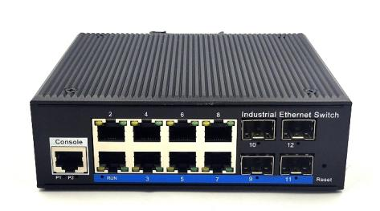

LBT48BGS-MN-SFP an hardened 12-port Industrial Ethernet Switch, provides non-blocking wire-speed performance in harsh industrial environment. It also provides 8-port 10/100/1000BASE-TX RJ45 +4G SFP delivered in an IP40 rugged, strong case with redundant power system. Its slim case is suitable for such applications as surveillance system deployments, control management and wireless service in climatically demanding environments with wide temperature range from -40℃ to 80℃.
Features
- Data control: support 802.3x full duplex flow control, support network storm suppression
- Redundant network: support STP/RSTP/MSTP, support ERPS (self-healing time <20ms)
- Support IPv6, static routing
- Support DHCP Server, DHCP replay, Qos
- Multicast management: Support IGMP Snooping ，IGMP V1/V2/V3；Support GMRP ,static multicast
- Support port-based VLAN Port, IEEE 802.1Q VLAN and GVRP protocol, simple network planning
- QoS: Support QoS (IEEE 802.1p/1Q) and TOS/ Diffserv to increase network stability
- Security management: support ACL access control list, support 802.1x, support user classification management
- Management function: support Web, SNMP management mode
- Monitoring maintenance: support port mirroring, interface status monitoring, log management
- Alarm function: support power supply, port, abnormal state relay output
- Support 1588 clock protocal

The LBT48BGS-MN-SFP provides the flexibility to all kinds of 10//100/1000Mbps Ethernet Media on RJ-45 port and performs highly stable fiber performance.

The LBT48BGS-MN-SFP is packaged in a compact IP40 case that allows either DIN rail or panel mounting to have efficient usage of cabinet space. It provides an integrated power supply with a wide range of voltages for worldwide operation. It also offers dual-redundant, reversible polarity 12V DC to 52V DC power supply inputs for high availability applications requiring dual or backup power inputs.

Specifications:
ROBOT
ROBOT
Model No. | LBT48BGS-MN-SFP
1000Base-TX Port | 8 port RJ-45 auto-MDI / MDI-X
1000Base-FX Port | 4G SFP Slot
Performance Specification | Bandwidth(switch capacity): 76Gbps  Packet Buffer Memory:16Mbit  Packet Forwarding Rate: 56Mpps  MAC Address Table: 8K
Installation | DIN rail
Maximum Frame Size | 9600bytes
Flow Control | Back pressure for half duplex, IEEE 802.3x pause frame for full duplex
Enclosure | IP40 aluminum housing
LED Indicator | Power: Red  Fiber: Link 2(Green)  Ethernet: Yellow
Power Input | 12 to 52V DC redundant power
Power Consumption | <10 watts
Surge protection | ± 4KV
Network Protocols | IEEE802.3 10BASE-T;  IEEE802.3i 10Base-T;  IEEE802.3u;100Base-TX/FX;  IEEE802.3ab 1000Base-T;  IEEE802.3z 1000Base-X;  IEEE802.3x;
Network cables | 10BASE-T: Cat3,4,5 UTP(≤100 meter)  100BASE-TX: Cat5 or later UTP(≤100meter)  1000BASE-TX: Cat6 or later UTP(≤100 meter)
Industry Standard | FCC CFR47 Part 15,EN55022/CISPR22, Class A  IEC61000-4-2 (ESD): ±8kV (contact), ±12kV (air)  IEC61000-4-3 (RS): 10V/m (80~1000MHz)  IEC61000-4-4 (EFT): Power Port: ±4kV; Data Port: ±2kV  IEC61000-4-5 (Surge): Power Port: ±2kV/DM, ±4kV/CM; Data Port: ±2kV  IEC61000-4-6 (CS): 3V (10kHz-150kHz); 10V (150kHz-80MHz)  IEC61000-4-16 (Common mode conduction): 30V (cont.), 300V (1s)
Certification | CE FCC Rohs compliance
MTBF | >300,000hours
Dimensions (W x D x H) | 143x 125x 48 mm
Weight | Product Weight: 1.25KG Packing Weight: 1.4KG
Working Environment | Working temperature: -40～80℃ ;  Storage temperature: -40～80℃  Relative Humidity: 5%~95 %( no condensation)
Warranty | 1-year replacement with new item; 3-years for main parts.
Dimensions
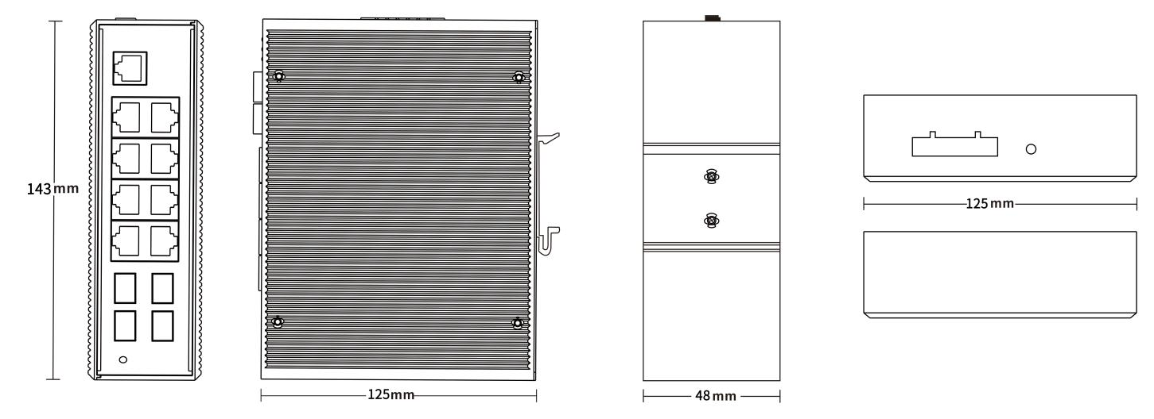
Ordering Information
LBT48BGS-MN-SFP | 8-port 10/100/100BASE-TX+4G SFP Managed Industrial Switch

