LBT1212BGS-SFP

12-port 10//100/1000BASE-TX+12G SFP Managed Industrial Switch
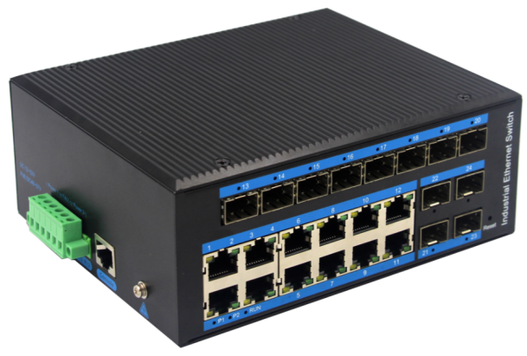

LBT1212BGS-SFP an hardened 24-port Industrial Ethernet Switch, provides non-blocking wire-speed performance in harsh industrial environment. It provides 12-port 10/100/1000BASE-TX RJ45 +12G SFP delivered in an IP40 rugged, strong case with redundant power system. Its slim case is suitable for such applications as surveillance system deployments, control management and wireless service in climatically demanding environments with wide temperature range from -40℃ to 80℃.
Features
- Data control: support 802.3x full duplex flow control, support network storm suppression
- Redundant network: support STP/RSTP/MSTP, support ERPS (self-healing time <20ms)
- Support IPv6, static routing
- Support DHCP Server, DHCP replay, Qos，IGMP Snooping
- Support port-based VLAN Port, IEEE 802.1Q VLAN and GVRP protocol, simple network planning
- QoS: Support QoS (IEEE 802.1p/1Q) and TOS/ Diffserv to increase network stability
- Security management: support ACL access control list, support 802.1x, support user classification management
- Management function: support Web, SNMP management mode
- Monitoring maintenance: support port mirroring, interface status monitoring, log management
- Support 1588 clock protocol

The LBT1212BGS-SFP provides the flexibility to all kinds of 10//100/1000Mbps Ethernet Media on RJ-45 port and performs highly stable fiber performance.

The LBT1212BGS-SFP is packaged in a compact IP40 case that allows either DIN rail or panel mounting to have efficient usage of cabinet space. It provides an integrated power supply with a wide range of voltages for worldwide operation. It also offers dual-redundant, reversible polarity 12V DC to 52V DC power supply inputs for high availability applications requiring dual or backup power inputs.

Specifications:
ROBOT
ROBOT
Model No. | LBT1212BGS-SFP
1000Base-TX Port | 12 port RJ-45 auto-MDI / MDI-X
1000Base-FX Port | 12G SFP Slot
Performance Specification | Bandwidth(switch capacity): 106Gbps  Packet Buffer Memory:16Mbit  Packet Forwarding Rate: 78Mpps  MAC Address Table: 8K
Installation | DIN rail
Maximum Frame Size | 9600bytes
Flow Control | Back pressure for half duplex, IEEE 802.3x pause frame for full duplex
Enclosure | IP40 aluminum housing
LED Indicator | Power: Red  Fiber: Link 2(Green)  Ethernet: Yellow
Power Input | 12 to 52V DC redundant power
Power Consumption | <10 watts
Surge protection | ± 4KV
Network Protocols | IEEE802.3 10BASE-T;  IEEE802.3i 10Base-T;  IEEE802.3u;100Base-TX/FX;  IEEE802.3ab 1000Base-T;  IEEE802.3z 1000Base-X;  IEEE802.3x;
Network cables | 10BASE-T: Cat3,4,5 UTP(≤100 meter)  100BASE-TX: Cat5 or later UTP(≤10meter)  1000BASE-TX: Cat6 or later UTP(≤100 meter)
Industry Standard | FCC CFR47 Part 15,EN55022/CISPR22, Class A  IEC61000-4-2 (ESD): ±8kV (contact), ±12kV (air)  IEC61000-4-3 (RS): 10V/m (80~1000MHz)  IEC61000-4-4 (EFT): Power Port: ±4kV; Data Port: ±2kV  IEC61000-4-5 (Surge): Power Port: ±2kV/DM, ±4kV/CM; Data Port: ±2kV  IEC61000-4-6 (CS): 3V (10kHz-150kHz); 10V (150kHz-80MHz)  IEC61000-4-16 (Common mode conduction): 30V (cont.), 300V (1s)
Certification | CE FCC Rohs compliance
MTBF | >300,000hours
Dimensions (W x D x H) | 166×137×68.5mm
Weight | Product Weight: 1.35KG Packing Weight: 1.45KG
Working Environment | Working temperature: -40～80℃ ;  Storage temperature: -40～80℃  Relative Humidity: 5%~95 %( no condensation)
Warranty | 1-year replacement with new item; 3-years for main parts.
Management features:
Interface | IEEE802.3X (Full-duplex), Port temperature protection setting  Port green Ethernet Energy-saving setting Broadcast storm control based  on port speed. The speed limit of the message flow in the access port.  The minimum particle size is 64Kbps.
Layer 3 Features | L2+ network management, IPV4/IPV6 management L3 soft routing forwarding,  Static route, Default route @ 128 pcs, APR@1024pcs
VLAN | 4K VLAN based on port, IEEE802.1q  VLAN based on the protocol  VLAN based on MAC  Voice VLAN, QinQ configuration  Port configuration of Access, Trunk, Hybrid
Port Aggregation | LACP, Static aggregation  Max 8 aggregation groups and 8 ports per group.
Spanning Tree | STP (IEEE802.1d), RSTP (IEEE802.1w), MSTP (IEEE802.1s)
Industrial Ring  Network Protocol | G.8032 (ERPS), Recovery time less than 20ms  250 Ring at most, Max 250 devices per ring. Multicast
Multicast | MLD Snooping v1/v2,Multicast VLAN  IGMP Snooping v1/v2, Max 1024 multicast groups, Fast log out
Port Mirroring | Bidirectional data mirroring based on port
QoS | Flow-based Rate Limiting Flow-based Packet Filtering  8*Output queues of each port 802.1p/DSCP priority mapping  Diff-Serv QoS, Priority Mark/Remark  Queue Scheduling Algorithm (SP, WRR, SP+WRR)
ACL | Port-based Issuing ACL,ACL based on port and VLAN  L2 to L4 packet filtering, matching first 80bytes message.  Provide ACL based on MAC, Destination MAC address, IP Source,  Destination IP, IP Protocol Type, TCP/UDP Port, TCP/UDP Port Range,  and VLAN, etc.
Security | IP-MAC-VLAN-Port binding  ARP inspection, Anti-DoS attack AAA & RADIUS, MAC learning limit  Mac black holes, IP source protection IEEE802.1X & MAC  address authentication Broadcast storm control,Backup for host datum  SSH 2.0, SSL, Port isolation, ARP message speed limit  User hierarchical management and password protection
DHCP | DHCP Client, DHCP Snooping, DHCP Server, DHCP Relay
Management | One-key recovery Cable Diagnose, LLDP  Web Management (HTTPS) NTP, System work log,Ping Test CPU  instant utilization status view  Console/AUX Modem/Telnet/SSH2.0 CLI  Download & Management on FTP, TFTP, X modem, SFTP, SNMP V1/V2C/V3
System | Category 5 Ethernet network cable  Web browser: Mozilla Firefox 2.5 or higher, Google browser chrome  V42 or higher, Microsoft Internet Explorer10 or later;  TCP/IP, network adapter, and network operating system  (such as Microsoft Windows, Linux, or Mac OS X) installed on each  computer in a network

Dimensions
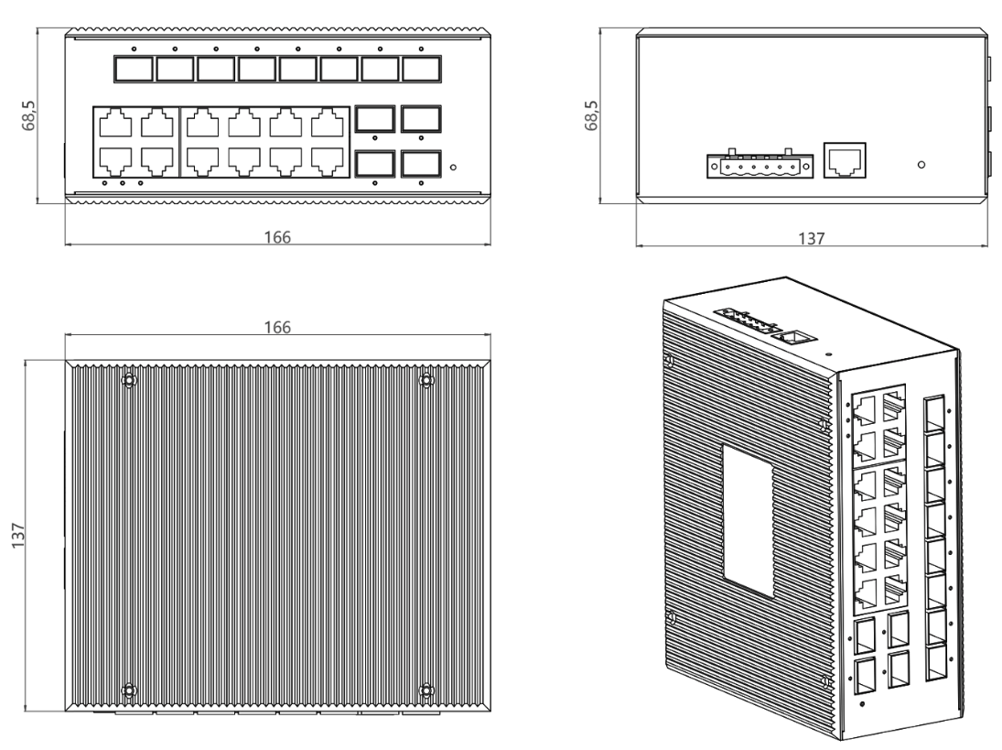Ordering Information
LBT1212BGS-SFP | 12-port 10/100/100BASE-TX+12G SFP Managed Industrial Switch

