LBT48GS-M-SFP

8-port 10//100/1000BASE-TX+4G SFP Managed Industrial Switch
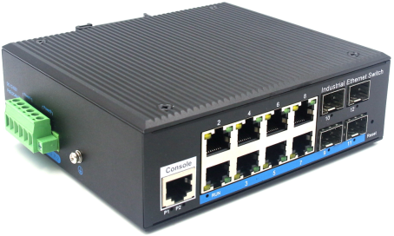
Interface
- 8-port 10/100/1000Base-Tx RJ-45 with auto negotiation and auto-MDI/ MDI-X function
- 4-port gigabit SFP

Industrial conformance
- 12V to 52V DC, redundant power input
- -40℃ to 80℃ operating temperature
- IP40 aluminum housing
- Supports 6KV DC Ethernet ESD protection
- Supports 6KV DC EFT protection for power line
- Free Fall, Shock and Vibration Stability
- DIN-rail and wall-mountable hardware design

Slim Type with more Practicability and Convenience
LBT48GS-M-SFP an hardened 12-port Industrial Ethernet Switch, provides non-blocking wire-speed performance in harsh industrial environment. It also provides 8-port 10/100/1000BASE-TX RJ45 +4G SFP delivered in an IP40 rugged, strong case with redundant power system. Its slim case is suitable for such applications as surveillance system deployments, control management and wireless service in climatically demanding environments with wide temperature range from -40℃ to 80℃.

The LBT48GS-M-SFP provides the flexibility to all kinds of 10/1000Mbps Ethernet Media on RJ-45 port and performs highly stable fiber performance.
L2 management
- Support STP/RSTP/MSTP/ERPS
- Web management, CLI
- IGMP snooping, QoS,VLAN
- SNMP v1/v2c/v3

The LBT48GS-M-SFP is packaged in a compact IP40 case that allows either DIN rail or panel mounting to have efficient usage of cabinet space. It provides an integrated power supply with a wide range of voltages for worldwide operation. It also offers dual-redundant, reversible polarity 12V DC to 52V DC power supply inputs for high availability applications requiring dual or backup power inputs.

Specifications:
ROBOT
ROBOT
Model No. | LBT48GS-M-SFP
1000Base-TX Port | 8 port RJ-45 auto-MDI / MDI-X
1000Base-FX Port | 4G SFP Slot
Performance Specification | Bandwidth: 56Gbps  Packet Buffer Memory: 12Mbit  Packet Forwarding Rate: 41.6Mpps  MAC Address Table: 8K
Installation | DIN rail
Maximum Frame Size | 10240bytes packet size
Flow Control | Back pressure for half duplex, IEEE 802.3x pause frame for full duplex
Enclosure | IP40 aluminum housing
LED Indicator | Power: Red  Fiber: Link 2(Green)  Ethernet: Yellow
Power Input | 12 to 52V DC redundant power
Surge protection | ± 4KV
Protection | ESD (Ethernet): 6KV DC  Surge (Power): 6KV DC
Network Protocols | IEEE802.3 10BASE-T;  IEEE802.3i 10Base-T;  IEEE802.3u;100Base-TX/FX;  IEEE802.3ab 1000Base-T;  IEEE802.3z 1000Base-X;  IEEE802.3x;
Network cables | 10BASE-T: Cat3,4,5 UTP(≤100 meter)  100BASE-TX: Cat5 or later UTP(≤100meter)  1000BASE-TX: Cat6 or later UTP(≤100 meter)
Industry Standard | FCC CFR47 Part 15,EN55022/CISPR22, Class A  IEC61000-4-2 (ESD): ±8kV (contact), ±12kV (air)  IEC61000-4-3 (RS): 10V/m (80~1000MHz)  IEC61000-4-4 (EFT): Power Port: ±4kV; Data Port: ±2kV  IEC61000-4-5 (Surge): Power Port: ±2kV/DM, ±4kV/CM; Data Port: ±2kV  IEC61000-4-6 (CS): 3V (10kHz-150kHz); 10V (150kHz-80MHz)  IEC61000-4-16 (Common mode conduction): 30V (cont.), 300V (1s)
Certification | CE FCC Rohs compliance
MTBF | >300,000hours
Dimensions (W x D x H) | 143×125×48mm
Weight | Product Weight: 1.25KG  Packing Weight: 1.4KG
Working Environment | Working temperature: -40～80℃ ;  Storage temperature: -40～80℃  Relative Humidity: 5%~95 %( no condensation)
Warranty | 1-year replacement with new item; 3-years for main parts.

Dimensions
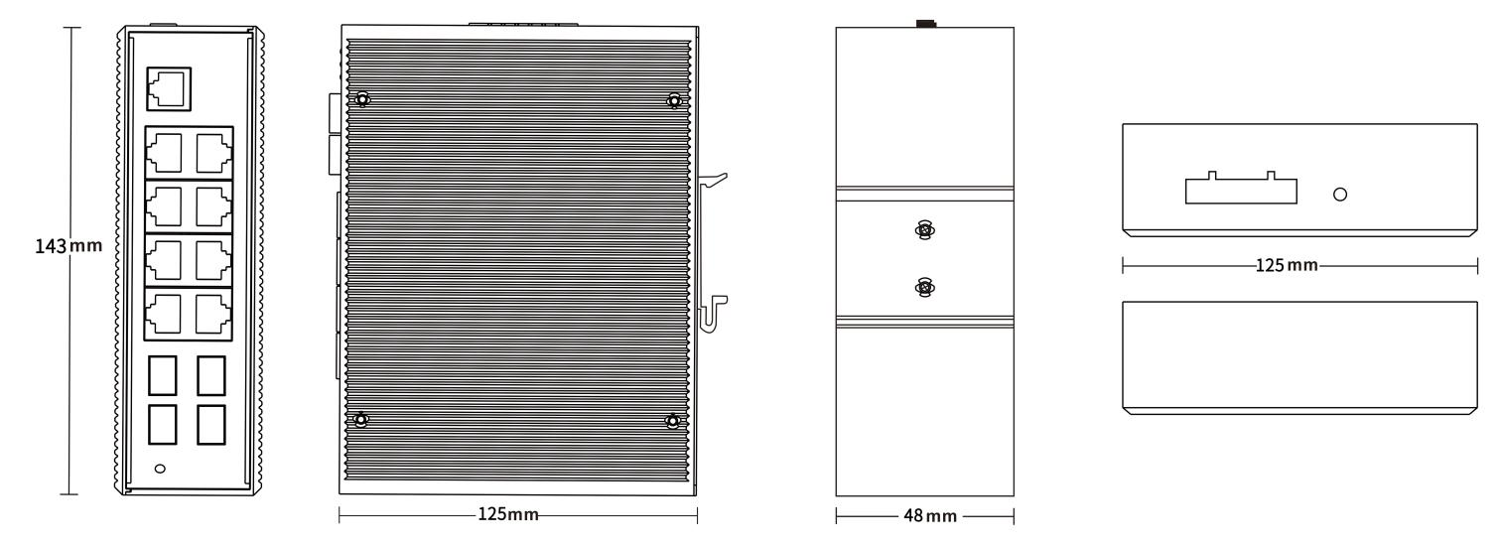

Ordering Information
LBT48GS-M-SFP | 8-port 10/100/100BASE-TX+4G SFP Managed Industrial Switch

