LBT216GS-M-SFP

16-port 10//100/1000BASE-TX+2G SFP Managed Industrial Switch
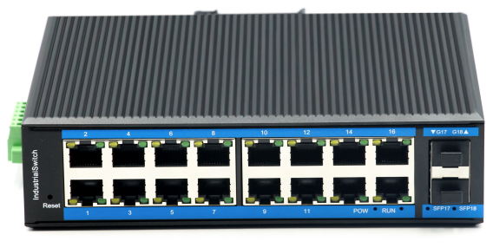

Interface
- 16-port 10/100Base-Tx RJ-45 with auto negotiation and auto-MDI/ MDI-X function
- 2-port gigabit SFP uplink

Industrial conformance
- 12V to 52V DC, redundant power input
- -40℃ to 80℃ operating temperature
- IP40 aluminum housing
- Supports 6KV DC Ethernet ESD protection
- Supports 6KV DC EFT protection for power line
- Free Fall, Shock and Vibration Stability
- DIN-rail and wall-mountable hardware design

LBT216GS-M-SFP an hardened 18-port Industrial Ethernet Switch, provides non-blocking wire-speed performance in harsh industrial environment. It also provides 16-port 10/100/1000BASE-TX RJ45 +2G SFP delivered in an IP40 rugged, strong case with redundant power system. Its slim case is suitable for such applications as surveillance system deployments, control management and wireless service in climatically demanding environments with wide temperature range from -40℃ to 80℃.

The LBT216GS-M-SFP provides the flexibility to all kinds of 10/100/1000Mbps Ethernet Media on RJ-45 port and performs highly stable fiber performance.

The LBT216GS-M-SFP is packaged in a compact IP40 case with DIN rail installation. It provides an integrated power supply with a wide range of voltages for worldwide operation. It also offers dual-redundant, reversible polarity 12V DC to 52V DC power supply inputs for high availability applications requiring dual or backup power inputs.
L2 management
- Support STP/RSTP/MSTP
- Web management, CLI
- IGMP snooping, QOS,VLAN,SNMP

Specifications:
ROBOT
ROBOT
Model No. | LBT216GS-M-SFP
1000Base-TX Port | 16 port RJ-45 auto-MDI / MDI-X
1000Base-FX Port | 2G SFP Slot
Performance Specification | Bandwidth: 56Gbps  Packet Buffer Memory: 12Mbit  Packet Forwarding Rate: 42Mpps  MAC Address Table: 8K
Installation | DIN rail
Maximum Frame Size | 10240bytes packet size
Flow Control | Back pressure for half duplex, IEEE 802.3x pause frame for full duplex
Enclosure | IP40 Aluminum housing
LED Indicator | Power: Red  Fiber: Link 2(Green)  Ethernet: Yellow
Power Input | 12 to 52V DC redundant power
Power Consumption | < 10W
Surge protection | ± 4KV
Network Protocols | IEEE802.3 10BASE-T;  IEEE802.3i 10Base-T;  IEEE802.3u;100Base-TX/FX;  IEEE802.3ab 1000Base-T;  IEEE802.3z 1000Base-X;  IEEE802.3x;
Network cables | 10BASE-T: Cat3,4,5 UTP(≤100 meter)  100BASE-TX: Cat5 or later UTP(≤100meter)  1000BASE-TX: Cat6 or later UTP(≤100 meter)
Industry Standard | FCC CFR47 Part 15,EN55022/CISPR22, Class A  IEC61000-4-2 (ESD): ±8kV (contact), ±12kV (air)  IEC61000-4-3 (RS): 10V/m (80~1000MHz)  IEC61000-4-4 (EFT): Power Port: ±4kV; Data Port: ±2kV  IEC61000-4-5 (Surge): Power Port: ±2kV/DM, ±4kV/CM; Data Port: ±2kV  IEC61000-4-6 (CS): 3V (10kHz-150kHz); 10V (150kHz-80MHz)  IEC61000-4-16 (Common mode conduction): 30V (cont.), 300V (1s)
Certification | CE FCC Rohs compliance
MTBF | >300,000hours
Dimensions (W x D x H) | 175.6 x 135 x 45.5 mm
Weight | Product Weight: 1.18KG  Packing Weight: 1.3KG
Working Environment | Working temperature: -40～80℃ ;  Storage temperature: -40～80℃  Relative Humidity: 5%~95 %( no condensation)
Warranty | 1-year replacement with new item; 3-years for main parts.

Software:
Port Features |  | IEEE 802.3x Flow control
 |  | Interface counters
 |  | Storm Control
Link Aggregation |  | Static Aggregation
 |  | Dynamic Aggregation, LACP
Supports up to 8 aggregation groups, each group up to 8 ports
Support source MAC, destination MAC, source destination MAC, source IP, destination IP, source destination IP routing strategy
MAC Table Management |  | Support
Forwarding mode |  | Support IVL forwarding mode
Static MAC Address |  | Support
MAC Address Binding |  | Support
MAC Address Filtering |  | Support
Mirror |  | Port-based Mirror
Spanning Tree |  | IEEE802.1d STP
 |  | IEEE802.1w RSTP
 |  | IEEE802.1s MSTP
ERPS (G.8032) |  | Single Ring, Sub-Ring, Multi-Ring
 |  | Load balance
 |  | Recovery Time < 50ms
GVRP |  | Supported
QINQ |  | VLAN-based QinQ
LLDP |  | LLDP
 |  | LLDP-MED
Loop Protection |  | Supported
VLAN |  | 4094 VLAN
 |  | Port-based VLAN
 |  | GVRP
Protocol VLAN |  | MAC-based VLAN
 |  | IP Subnet-based VLAN
Voice VLAN |  | Static entry
 |  | LLDP-MED
Port Isolate |  | Support
IGMP |  | Snooping IGMP V1 Snooping
 |  | IGMP V2 Snooping
 |  | IGMP V3 Snooping
 |  | Source Port Check
 |  | IGMP Fast Leave
 |  | IGMP Filter
MLD Snooping |  | MLD V1 Snooping
 |  | MLD V2 Snooping
 |  | Source Port Check
 |  | MLD Fast Leave
 |  | MLD Filter
Security
ACL |  | ACL (IP Standard ACL), IPv4/IPv6
 |  | MAC extend ACL
 |  | IP extend ACL
 |  | L2, L3, L4 fields match
 |  | log, redirection, mirroring, speed limit
QoS |  | QoS Class, Remarking
 |  | SP, WRR queue scheduling
 |  | Ingress port-based rate-limit
 |  | Ingress priority-based rate-limit
 |  | Egress port-based rate-limit
 |  | Egress queue-based rate-limit
 |  | Policy-based QoS
 |  | Storm Control
 |  | 8 queues per port
Dot1x |  | Port Access Control
 |  | User Access Control
 |  | MAC-address Access Control
AAA |  | Support 802.1x
 |  | Support RADIUS
 |  | Supports authentication, authorization, and accounting through RADIUS server
Management
User management |  |  | Password protection
SNMP |  |  | SNMP V1/V2c/V3
RMON |  |  | Statistics Group
 |  |  | History Group
 |  |  | Alarm Group
 |  |  | Events Group
Web management |  |  | HTTP V1.1, HTTPS
Firmware Upgrade |  |  | Reversion Upgrade
IPv4/IPv6 |  |  | Support
CLI |  |  | Support
Syslog/Debug |  |  | Support
Diagnosis |  |  | Ping (IPv4), ping (IPv6)
 |  |  | Trace route(IPv4)
 |  |  | Trace route(IPv6)
Management
NTP | NTP Client
DHCP | DHCPv4 Client, DHCPv6 Client
DHCP Snooping | DHCP snooping table
DHCP Snooping | Trust Port
IPv6 DHCP-Guard | Support
Telnet | Telnet Server
TFTP | TFTP Client
SSH | SSH Server

Dimensions
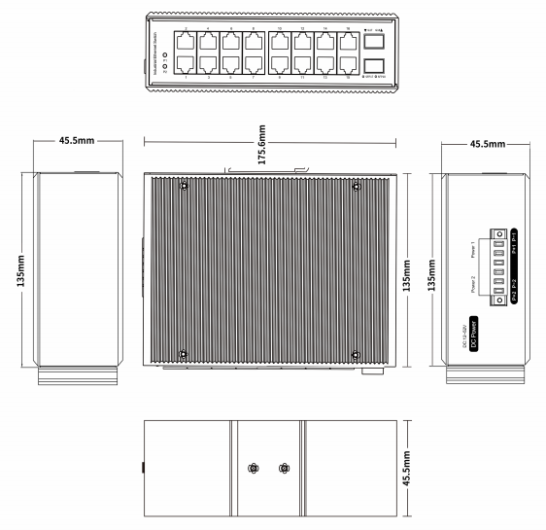

Ordering Information
LBT216GS-M-SFP | 16-port 10/100/100BASE-TX+2G SFP Managed Industrial Switch

