LBT48GST4-M-SFP

8 Port gigabit +4 Port 10G SFP L3 Managed Industrial Switch
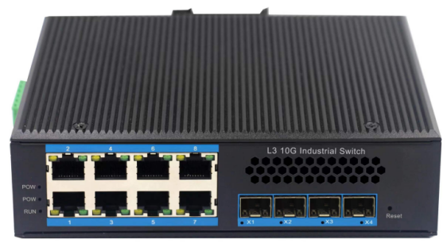

Rack mounted Aluminum Industrial Switch
Product features:
● Data control: Supports 802.3x full-duplex flow control and
network storm suppression
● Redundant network: supports STP, RSTP, MSTP and ERPS
● Redundancy backup: supports the virtual route redundancy protocol VRRP
● Multicast management: Support IGMP Snooping V1, V2, and V3
● VLAN: supports IEEE 802.1Q vlans to effectively isolate broadcast domains
Link aggregation: Support static/dynamic link aggregation, provide perfect bandwidth utilization
● QOS: Support COS\DSCP, 4 queues, support WRR\SP scheduling mode
● Security management: Security management: supports ACL and 802.1x
● Management: Supports WEB, CLI, and SNMP management
Monitoring and maintenance: Support port mirroring, interface status monitoring, log management

LBT48GST4-M-SFP switch is a high performance 8 Port gigabit + 10G SFP+ L3 core switch. It provides Static routing and dynamic routing with advanced hardware processing capacity. The machine adopts modular design, which supports up to 4 Port 10G SFP+, and retains the expansion ability to further support 10GE when realizing gigabit convergence or access. It supports IPv4/IPv6 hardware double stack and line speed forwarding, so that customers can easily cope with the coming IPv6 era, which provides high capacity exchange capacity. LBT48GST4-M-SFP switch has the operating temperature of -40℃ ~ 85℃, has the super firmness to adapt to all kinds of harsh environment, can also be very convenient to install in the machine room cabinet. The rack-mounted characteristics and wide temperature operation make the switch a plug and play industrial-grade device, providing a reliable and convenient solution for users to network their Ethernet devices.

Strong processing ability
LBT48GST4-M-SFP switch is based on the powerful and stable
processing power of VCore-III MIPS-based CPU
LBT48GST4-M-SFP provides up to 1.2Tbps of switching capacity
port full speed filtering and forwarding 406Mpps
To ensure that the trunk network of large traffic data without blocking
Forwarding.

Specifications:
ROBOT
ROBOT
Model No. | LBT48GST4-M-SFP
Interface | 8-Port 10/100/1000Mbps RJ45  4-Port 10G SFP+ (compatible with 1000M/2500M/10000M)  1-Port console
Performance Specification | Bandwidth(switch capacity): 1.2Tbps  Packet Buffer Memory:32Mbit  Packet Forwarding Rate: 406Mpps  MAC Address Table: 32K
Installation | Bracket mounted
Maximum Frame Size | 10240bytes
Flow Control | Back pressure for half duplex, IEEE 802.3x pause frame for full duplex
Enclosure | IP40 Aluminum housing
LED Indicator | POWER: Red  RUN: Green  Fiber: X1~X4(Green)  Ethernet: Green
Power Input | DC 12V -52V
Power Consumption | < 18watts
Surge protection | ±4KV
Network Protocols | IEEE 802.3ad, link aggregation protocols  IEEE802.3 10BASE-T;  IEEE802.3i 10Base-T;  IEEE802.3u;100Base-TX/FX;  IEEE802.3ab 1000Base-T;  IEEE802.3z 1000Base-X;  IEEE 802.3ae,10G  IEEE 802.3x, Full duplex Ethernet data link Laminar flow control  IEEE 802.3az,EEE high efficient ethernet
Network cables | 10BASE-T: Cat3,4,5 UTP(≤100 meter)  100BASE-TX: Cat5 or later UTP(≤100meter)  1000BASE-TX: Cat6 or later UTP(≤100 meter)
Industry Standard  (EMC 4) | FCC CFR47 Part 15,EN55022/CISPR22, Class A  IEC61000-4-2 (ESD): ±8kV (contact), ±12kV (air)  IEC61000-4-3 (RS): 10V/m (80~1000MHz)  IEC61000-4-4 (EFT): Power Port: ±4kV; Data Port: ±2kV  IEC61000-4-5 (Surge): Power Port: ±2kV/DM, ±4kV/CM; Data Port: ±2kV  IEC61000-4-6 (CS): 3V (10kHz-150kHz); 10V (150kHz-80MHz)  IEC61000-4-16 (Common mode conduction): 30V (cont.), 300V (1s)
Certification | CE FCC Rohs compliance
MTBF | >300,000hours
Dimensions (W x D x H) | 175.6 x 135 x45.5mm
Weight | Product Weight: 0.8KGS  Packing Weight: 0.9KGS
Working Environment | Working temperature: -40～85℃ ;  Storage temperature: -40～85℃  Relative Humidity: 5%~95 %( no condensation)
Warranty | 1-year replacement with new item; 3-years for main parts.

Management features:
Interface | IEEE802.3X (Full-duplex), Port temperature protection setting  Port green Ethernet Energy-saving setting Broadcast storm control based  on port speed. The speed limit of the message flow in the access port.  The minimum particle size is 64Kbps.
Layer 3 Features | L3 network management, IPV4/IPV6 management L3 soft routing forwarding,  Static route, Default route @ 128 pcs, APR@1024pcs
VLAN | 4K VLAN based on port, IEEE802.1q  VLAN based on the protocol  VLAN based on MAC  VLAN based on IP  Voice VLAN, QinQ configuration  Port configuration of Access, Trunk, Hybrid
Port Aggregation | LACP, Static aggregation  Max 14 aggregation groups and 16 ports per group.
Spanning Tree | STP (IEEE802.1d), RSTP (IEEE802.1w), MSTP (IEEE802.1s)
Industrial Ring  Network Protocol | G.8032 (ERPS), Recovery time less than 20ms  250 Ring at most, Max 250 devices per ring. Multicast
Multicast | MLD Snooping v1/v2,Multicast VLAN Registration (MVR)  IGMP Snooping v1/v2, Max 1024 multicast groups, Fast log out
Port Mirroring | Bidirectional data mirroring based on port
QoS | SP（Strict Priorty）  WFQ (Weighted Fair Queuing)  WRR (Weighted Round Robin)  Random Early Detect (RED)  WeightedRandomEarlyDetection (WRED)  Head Of Line  Best-Effort Service  First come first served  802.1p  Cos/Tos，QOS  Differentiated Service
ACL | Port-based Issuing ACL,ACL based on port and VLAN  L2 to L4 packet filtering, matching first 80bytes message.  Provide ACL based on MAC, Destination MAC address, IP Source,  Destination IP, IP Protocol Type, TCP/UDP Port, TCP/UDP Port Range,  and VLAN, etc.
Security | Support IP ACL，MAC ACL，Vlan ACL,support ACL based on L3 L4  IP+MAC Port binding  Support IP Source Guard, RP Detection  Support IEEE 802.1x port verification, support Radius
DHCP | DHCP Client, DHCP Snooping, DHCP Server, DHCP Relay
IP routing | Supports port-based input/output bandwidth management.  Supports static routes. IPV6  Supports the virtual route redundancy protocol VRRP.  Dynamic routes such as RIP, RIPng, OSPF, and OSPFv3 are supported.
System maintenance | Supports configuration file uploading and downloading. Upload the upgrade package.  Supports factory restore on WEB, Supports the system log function.  Support Ping 、tracert、cable detection and other diagnostic functions.  Supports WEB management (HTTP and HTTPS).  Supports CLI management. Supports Telnet remote management.  Supports SSH 2.0. Supports SNMP network management.  Support RMON; Supports NTP clients. Support PTP（1588v2）

Dimensions
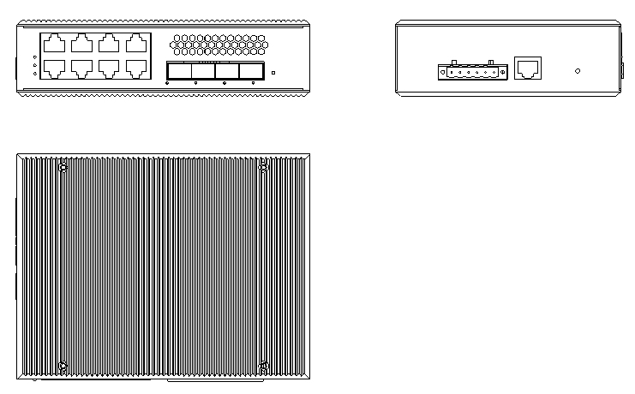

Ordering Information
LBT48GST4-M-SFP | 8-Port gigabit + 4-Port 10G SFP L3 Managed Industrial Switch

