300Mbps Outdoor Wireless Access Point

Model: T300-AP20Q

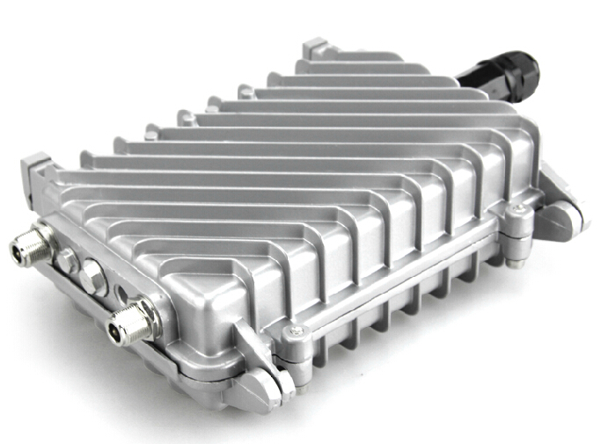

Description:

T300-AP20Q is an Qualcomm Chipset Outdoor wireless AP/CPE. It comply with IEEE 802.11b/g/n standard, 300Mbps high speed, with N type antenna connector, 800mW high power for wider outdoor wifi range.

It support wireless AP, Gateway, WiFi Repeater, Bridge, WISP, WDS operation mode, then with N type connector for detachable omni/panel antenna, user can flexibly choose a suitable wireless mode to build or extend the wireless networking based on exist networking structure.

T300-AP20Q with metal waterproof, dustproof and sunscreen shell, temperature adaptive and board protective to work in harsh outdoor environment, meanwhile, the auxiliary cooling function make T300-AP20Q work normal at -20℃ to 55℃.

T300-AP20Q support special frequency from 2.312GHz to 2.4835GHz, total 27 channels to avoid the WiFi Interference, to guarantee the stable wireless connection.

Meantime, it support Power over Ethernet, support passive PoE, easy in setup even no power socket nearby.

Last and important, T300-AP20Q work with Yuncore’s AC controller for central management under wireless AP operation mode, then can work with cloud server for captive portal authentication or advertisement when AC controller or T300-AP20Q under gateway operation mode..

Specification:
Hardware:
Chipset | Qualcomm QCA9531
Wireless | 802.11N, 2T2R 300M MIMO Technology
Memory | 64MB DDR2 RAM (128MB available by extra cost)
Flash | 16MB
Interface | 1* 10/100 Mbps RJ45 Port, support 12~24V PoE
Interface | 1 * Reset Button
Antenna | SMA Connector, can connect with panel antenna/omni antenna
LED Light | Power, WiFi
Size | L: 153.2mm, W: 79.5mm, H: 234.5 mm
Power | POE 24V/1A (48V PoE is optional);110V/220V
RF Date:
RF Data | 802.11b/g/n:
RF Data | 2.312GHz to 2.4835GHz
RF Data | Korea, Japan, ETSI, FCC, Debug
Modulation | OFDM = BPSK,QPSK, 16-QAM, 64-QAM
Modulation | DSSS = DBPSK, DQPSK, CCK
Data Rate | 300 Mbps
Receive Sensitivity | 802.11n: -70dbm@MCS7, -88dbm@MCS0.  802.11g: -72dbm@54Mbps, -88dbm@6Mbps.  802.11b: -85dbm@11Mbps, -94dbm@1Mbps.
RF Output Power | 802.11n: @MCS7:25±2DB, @MCS0:27±2DB.  802.11g: @54M:26±2DB, @6M:28±2DB.  802.11b: @11M:27±2DB, @1M:29±2DB
EVM | 802.11n: ≤-28 DB  802.11g: ≤-25 DB  802.11b: ≤-10 DB
PPM | ±20ppm

Firmware
Operation Mode | Gateway/AP/WiFi Repeater/WISP/WDS
Protocol/Standard | IEEE 802.3(Ethernet)
Protocol/Standard | IEEE 802.3u(Fast Ethernet)
Protocol/Standard | IEEE 802.11b/g/n(2.4G WLAN)
Wireless | Auto-Channel selection
Wireless | Distance Control (802.1x Ack timeout)
Wireless | Multiple SSID (4 SSID)
Wireless | BSSID
Security | WEP Encryption-64/128/152 bit
Security | WPA/WPA2 Personal (WPA-PSK using TKIP or AES)
Security | WPA/WPA2 Enterprise (WPA-EAP using TKIP)
Security | Hide SSID
System Setting | Web-based configuration (HTTP/Telnet)
Firmware upgrade | Upgrade firmware via web browser or TFTP
Administration | Admin Password can be configured
System monitoring | Status in hand , useful statistic and Event log
Log | Supports local logs, logs host, logs file export
Reset | Reset or factory defaults
Backup | Restore settings & configuration of the device to local file
Physical Property:
Temperature | Working: -20°C~55°C
Temperature | Storage: -40°C to 70°C
Humidity | 5%~95% (typical)
Package:
T300-AP20Q unit

PoE Adapter
User Manual
LAN Cable

Remark: antenna is optional by extra cost.

Accessory Pictures:
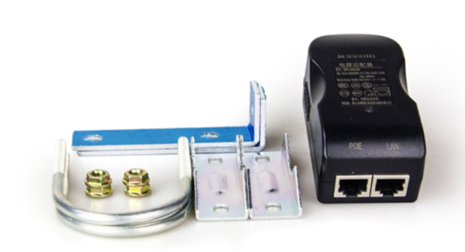

T300-AP20Q Application:
- Work with omni antenna for wifi coverage: 2. Work with Panel antenna for wifi transmit
