11ax 3000Mbps Outdoor Wireless AP-Omni Antenna
Model:T300-HQ830-P2

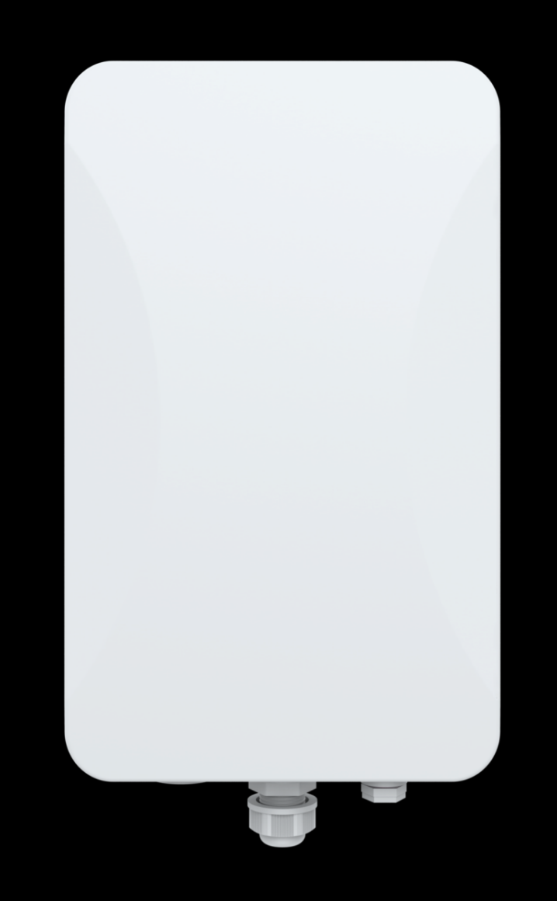

Description:
T300-HQ830-P2 is a high-performance 4T4R dual-band 802.11AX product that can provide 2.4G and 5.8GHz dual-band wireless services. 2.4G provides a maximum access rate of 574Mbps, and 5G provides a maximum access rate of 2402Mbps.

Main Features:
- Has better transmission quality, higher transmission rate, and concurrent rate up to 3000Mbps.
- Using IPQ5018 chip, it greatly expands the user capacity and can support 128 users.
- The heat sink adopts snap-on structure design and surface nano-coating treatment, which makes the heat dissipation effect more ideal.
- The radio frequency uses high-power FEM, which has stable performance and farther coverage.
- The addition of lightning protection board components greatly enhances the protection capabilities of the equipment;

Hardware Specification:
Model | T300-HQ830-P2
CPU | IPQ5018 + QCN6102
Flash | SPI NOR 8MB SPI NAND 128MB
DDR3 | 512MB*1
2.4G working frequency | 2.4GHz ~ 2.484GHz
2.4G WIFI protocol | 802.11 b / g / n / ac / ax
5G working frequency | 5.150GHz～5.825GHz
5G WIFI protocol | 802.11 a / n / ac / ax
Internal 2.4G | 2*2.4G: 5dBi
Internal 5G | 2*5.8G: 7dBi
Max rate | 2.4G: 574Mbps; 5G: 2402Mbps
2.4G TX Power | 802.11b | 11M | 24±2dBm | 1M | 24±2dBm
2.4G TX Power | 802.11g | 54M | 21±2dBm | 6M | 23±2dBm
2.4G TX Power | 802.11n HT20 | MCS7 | 20±2dBm | MCS0 | 22±2dBm
2.4G TX Power | 802.11n HT40 | MCS7 | 20±2dBm | MCS0 | 22±2dBm
2.4G TX Power | 802.11ax HE20 | MCS11 | 18±2dBm | MCS0 | 22±2dBm
2.4G TX Power | 802.11ax HE40 | MCS11 | 18±2dBm | MCS0 | 22±2dBm
5G TX Power | 802.11a | 54M | 19±2dBm | 6M | 22±2dBm
5G TX Power | 802.11n HT20 | MCS7 | 18±2dBm | MCS0 | 21±2dBm
5G TX Power | 802.11n HT40 | MCS7 | 18±2dBm | MCS0 | 21±2dBm
5G TX Power | 802.11ac VHT20 | MCS9 | 17±2dBm | MCS0 | 21±2dBm
5G TX Power | 802.11ac VHT40 | MCS9 | 17±2dBm | MCS0 | 21±2dBm
5G TX Power | 802.11ac VHT80 | MCS9 | 17±2dBm | MCS0 | 21±2dBm
5G TX Power | 802.11ax HE20 | MCS11 | 17±2dBm | MCS0 | 21±2dBm
5G TX Power | 802.11ax HE40 | MCS11 | 17±2dBm | MCS0 | 21±2dBm
5G TX Power | 802.11ax HE80 | MCS11 | 17±2dBm | MCS0 | 21±2dBm
5G TX Power | 802.11ax HE160 | MCS11 | 17±2dBm | MCS0 | 21±2dBm
2.4G Receiving Sensitivity | 802.11b | 11M | -85dBm | 1M | -90dBm
2.4G Receiving Sensitivity | 802.11g | 54M | -72dBm | 6M | -90dBm
2.4G Receiving Sensitivity | 802.11n HT20 | MCS7 | -70dBm | MCS0 | -87dBm
2.4G Receiving Sensitivity | 802.11n HT40 | MCS7 | -68dBm | MCS0 | -85dBm
2.4G Receiving Sensitivity | 802.11ax HE20 | MCS11 | -60dBm | MCS0 | -83dBm
2.4G Receiving Sensitivity | 802.11ax HE40 | MCS11 | -56dBm | MCS0 | -83dBm
5G Receiving Sensitivity | 802.11a | 54M | -72dBm | 6M | -92dBm
5G Receiving Sensitivity | 802.11n HT20 | MCS7 | -70dBm | MCS0 | -90dBm
5G Receiving Sensitivity | 802.11n HT40 | MCS7 | -68dBm | MCS0 | -88dBm
5G Receiving Sensitivity | 802.11ac VHT20 | MCS8 | -70dBm | MCS0 | -88dBm
5G Receiving Sensitivity | 802.11ac VHT40 | MCS9 | -68dBm | MCS0 | -88dBm
5G Receiving Sensitivity | 802.11ac VHT80 | MCS9 | -58dBm | MCS0 | -85dBm
5G Receiving Sensitivity | 802.11ax HE20 | MCS11 | -62dBm | MCS0 | -88dBm
5G Receiving Sensitivity | 802.11ax HE40 | MCS11 | -58dBm | MCS0 | -86dBm
5G Receiving Sensitivity | 802.11ax HE80 | MCS11 | -55dBm | MCS0 | -84dBm
5G Receiving Sensitivity | 802.11ax HE160 | MCS11 | -51dBm | MCS0 | -82dBm
2.4G EVM | 802.11b:≤-10 dB ；802.11g: ≤-25 dB ；802.11n:≤-28 dB；802.11ax:≤-35 dB
5G EVM | 802.11a:≤-25 dB ；802.11n: ≤-28 dB ；802.11ac:≤-32 dB；802.11ax:≤-35 dB
ppm | ±20ppm
WAN | 1*10/100/1000M support 48V POE
LAN | 1*Console port
Reset | Reset to factory settings by pressing 6-10 seconds
Indicators | PWR, SYS, WAN, 2.4G, 5.8G
Power | PoE 802.3at
Max Power Consumption | <16W
Dimension | 304mm × 181mm × 88mm
Weight | 1.6kg
Temperature | Working: -20°C to 55°C；Storage: -40°C to 70°C；Humidity: 5％～95％(Non-Condensing)
IP Grade | IP67
ESD | Air:±8K, Touch:±4K
Electrical Surge | Common Mode: 4K, Differential Mode: 2K

Firmware
Home Page | Working mode: FIT/ FAT mode
Home Page | Wireless AP download rate, wireless AP upload rate, runtime
Home Page | Device information, device description, intranet information, WIFI information
Working Mode | Gateway mode: The device connects to the wide area network through a WAN port and then uses static IP, DHCP, or PPPOE to connect to the internet
Working Mode | AP mode: The device covers other clients and devices with wireless network signals, and connects to other routers through Ethernet to access the wide area network
Wireless feature | SSID broadcasting
Wireless feature | SSID quantity: 4 (2.4GHz)+4()5GHz)
Wireless feature | Hide SSID
Wireless feature | Wireless encryption: OPEN、WPA/WPA2PSK-TKIPAES、WPA3PSK-TKIPAES
Wireless feature | MAC filter
Wireless feature | Band steering (5G WiFi priority)
Wireless feature | WiFi timed shutdown
Wireless feature | User isolation: wireless network isolation, AP internal isolation
Wireless feature | TX power adjustable
Wireless feature | Wireless client quantity limit
Wireless feature | QoS: WMM
Network feature  Cloud Platform Server | Connection method: static address, obtained from management server, obtained from gateway
Network feature  Cloud Platform Server | DHCP server: It can be either a built-in DHCP server or an external DHCP server
Network feature  Cloud Platform Server | Cloud Platform Server support
Network feature  Cloud Platform Server | Firewall
Network feature  Cloud Platform Server | PPPOE
Device management | Backup
Device management | Recovery
Device management | Reset to factory
Device management | Timed reboot/ Instant reboot
Device management | Firmware upgrade
Device management | System log
Device management | FIT/ FAT AP switch

Interface
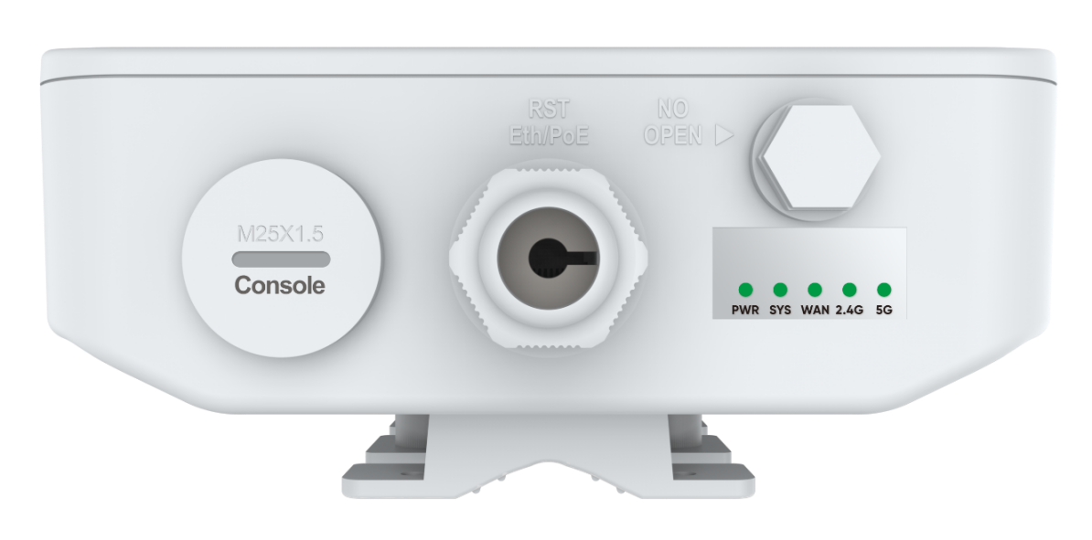

Dimension
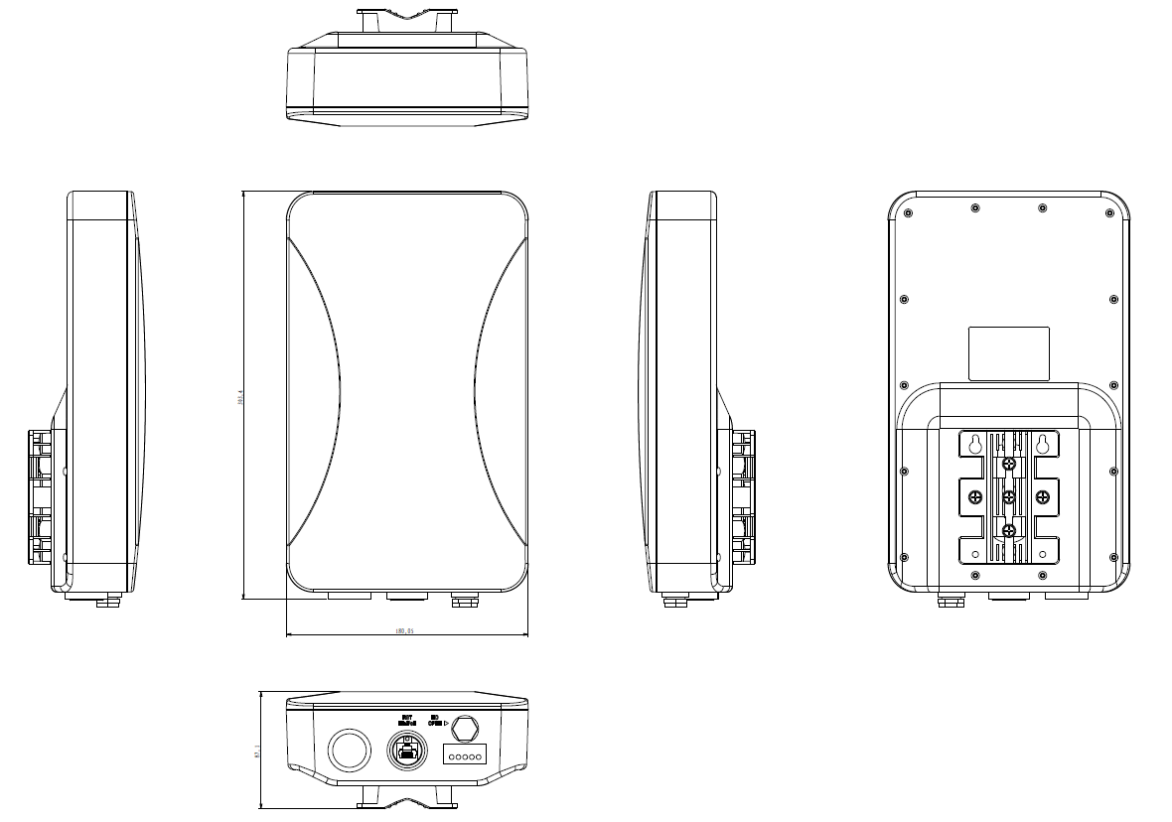

Accessory
AP | 1
Mounting Accessories | 2
Gift Box | 1

